Articles and Questions

Each **free article** of ***The Canadian Reader*** includes:   
  
1) a PDF file

*and*

2) a Word file

These files contain **only** the article and questions. They do **not** contain Answer Keys.

This **Word** file allows students to complete assignments using a computer either at school or at home. Teachers can assign all or parts of the file by email attachment or a school website. The **Word** file also allows teachers to:

• easily modify and format content including changing *fonts* and text sizes

• create a PDF document and use Adobe Reader's 'Read Out Loud Mode'

• save paper and copying costs and help protect the environment

• promote and encourage students’ computer skills

What Else Can You Do With The Word File?

#1) You can easily upload the file to Google Docs and share it with students or other teachers. **See how here:**

<https://support.google.com/drive/answer/2424368?hl=en>

#2) Translate the uploaded document into another language. (see **Tools>Translate document**).Google Docs will create a new copy of the original file but you will need to edit the document to suit your requirements. Google Docs can translate into over 100 languages including Spanish, Mandarin, German, etc. **See how here:**

<https://support.google.com/docs/answer/187189?hl=en&co=GENIE.Platform=Desktop>

**Alec Bélanger: Extra Awesome**

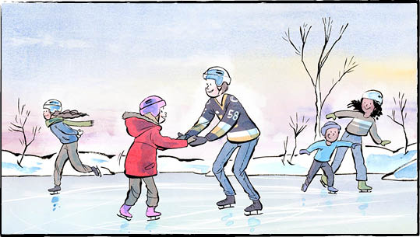

Alec Bélanger has played hockey his whole life. The 21-year‑old forward even plays hockey at school. Mr. Bélanger goes to Dalhousie University. The school is in Nova Scotia.

Mr. Bélanger brought something important with him to Dalhousie. It wasn’t his textbook. It wasn’t his hockey skates. It was something he couldn’t pack. Something he didn’t want to live without.

He brought along an idea for a program. An Extra Awesome program.

**Community service**

Before university, Mr. Bélanger played in the Ontario Hockey League. His coaches taught more than hockey skills. They taught the players to volunteer in the community.

Mr. Bélanger was a teenager. He didn’t understand. Why volunteer? What did helping have to do with hockey?

André Tourigny coached the Ottawa team. Mr. Bélanger played there for a time. Mr. Tourigny views hockey players as role models. They can help people and change lives. “It’s an unbelievable power,” the coach says.

But volunteer work won’t improve anyone’s hockey skills. Or will it?

When they volunteer, the players see what other people go through. They see people who are resilient and never quit. When you see that, “It’s tough to feel sorry for yourself,” Mr. Tourigny said.

**Extra Awesome**

In 2021-22, Mr. Bélanger played for the Kingston Frontenacs. One day, he was sent to skate with some kids. They were part of a program called Extra Awesome.

The program is run by Queen’s University students. Student volunteers spend time with kids who have Down Syndrome, and their siblings. They do fun activities. Sometimes it’s Bingo. Sometimes it’s a scavenger hunt. Sometimes they play catch.

Sometimes they work on reading or schoolwork together. Extra Awesome is about support and friendship.

One visit with this awesome group wasn’t enough. Mr. Bélanger went back again and again! “Every time I would leave with a smile on my face,” he says.

**A big job**

Mr. Bélanger started an Extra Awesome program at Dalhousie. It was a big job. He found a space. He recruited volunteers and participants. He even arranged insurance. One of his friends from the Kingston group helped him.

In January 2024, the program launched! They meet every Sunday. The program will run until the end of the school year.   
Mr. Bélanger hopes to plan some summer events, too.

This year, Mr. Bélanger won an award for his hockey playing. He was named Rookie of the Year. He won a community service award, too. That award honoured his work with Extra Awesome.

For Mr. Bélanger, the program itself is the reward. It’s even more important to him than hockey. “I live my week around this,” he says.

What questions would you like to ask Mr. Bélanger?

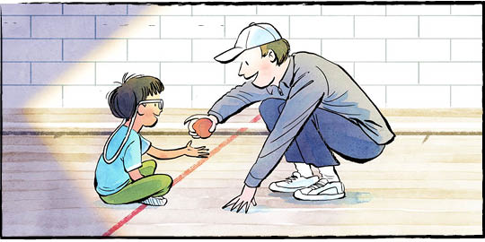

**Kids who have Down Syndrome are born with an extra copy of a chromosome.   
Can you guess where the name “Extra Awesome” might have come from?**

**Comprehension Check**

Mark the statements **T** (True) or **F** (False). If a statement is ***true***, write one fact to support it on the lines below. If a statement is ***false***, write the word or words that make it true on the lines below.

______ **1**. Dalhousie University is in Nova Scotia.

______ **2**. Mr. Bélanger’s coaches did not want him to volunteer in the community.

______ **3**. The Extra Awesome program is run by the Kingston Frontenacs.

______ **4**. Extra awesome volunteers spend time with kids who have Down Syndrome.

______ **5**. Mr. Bélanger’s Extra Awesome program launched in 2021-22.

______ **6**. This year, Mr. Bélanger won a community service award.

**Language Focus**

In English, there are three basic **verb tenses**: **past, present, and future**. Tenses indicates when in time an action or event happened.

**Directions**: Complete the table below with appropriate **past** or **present** tenses.



*Find three more examples of verbs in the past and present tenses from the article, or think of your own:*



**Can you identify patterns in each tense (words or endings)?**