Articles and Questions
Each issue of What in the World? includes:
1) a PDF file (the complete document) and
2) a Word file that contains only the articles and questions. This file does not contain an Answer Key.
This Word file allows students to complete assignments using a computer either at school or at home. Teachers can assign all or parts of the file by email attachment or a school website. The Word file also allows teachers to:
• easily modify and format content including changing fonts and text sizes
• create a PDF document and use Adobe Reader's 'Read Out Loud Mode'
• save paper and copying costs and help protect the environment
• promote and encourage students’ computer skills

Access Data
There are two main ways to access the data in this Word file:
1) Open the Word file and select the data you wish to Copy. Then Paste the data it into any word processing or email program. Use Select All to copy the entire document.
2) Most word processing programs will open Word files. You can use LibreOffice or Open Office (or another similar free program) to open and save .doc Word files.
See: www.libreoffice.org/discover/libreoffice/ www.openoffice.org

What Else Can You Do With The Word File?
#1) You can easily upload the file to Google Drive and share it with students or other teachers. See how here:
https://support.google.com/drive/answer/2424368?hl=en
#2) Translate the uploaded document into another language. (see Tools>Translate document). Google Docs will create a new copy of the original file but you will need to edit the document to suit your requirements. Google Docs can translate into over 100 languages including Spanish, Mandarin, German, etc. See how here:
https://support.google.com/docs/answer/187189?hl=en&co=GENIE.Platform=Desktop

Albertans Are Going To The Polls
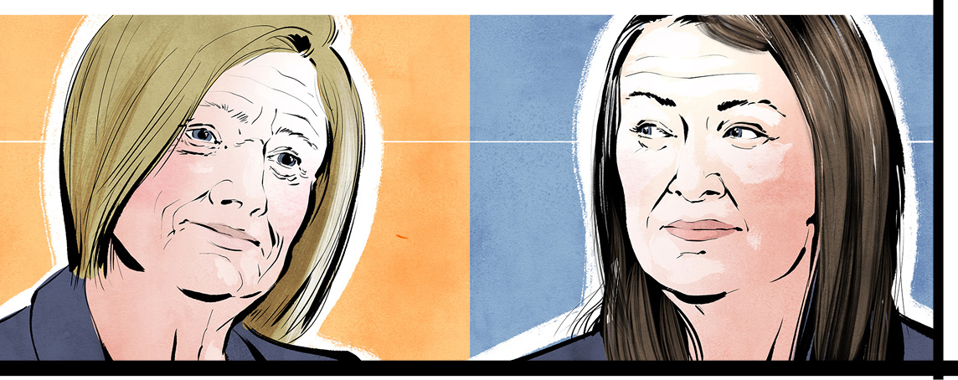

Albertans will head to the polls on May 29. They will vote to decide who will form the next government and become premier.
The race for the top post is between two women. Incumbent Premier Danielle Smith heads the United Conservative Party (UCP). Rachel Notley leads the New Democratic Party (NDP). She was the Alberta premier from 2015 to 2019.
The UCP is to the right of centre on the political spectrum. That means its members prefer fewer government programs. They support individual freedoms and responsibilities. The NDP is left of centre. Its members believe that government programs must address social issues like poverty.
Alberta has 87 legislature seats. One party must take 44 to win. Since 2019, the UCP has had a big majority government of 63 seats. The NDP has just 23.

Too close to call
In early May, however, analysts said that just one or two seats could decide the contest. Why is this race so close?
Polls suggest Albertans were unhappy over how the UCP handled the COVID-19 pandemic. As the crisis wore on, the UCP waffled about lockdowns, vaccines, and mask mandates. That caused spikes in the outbreak and triggered a severe healthcare emergency. In 2022, anger over the issue forced then-UCP premier Jason Kenney to resign. Ms. Smith took over as party leader. While this played out, the NDP gained support.
On the other hand, Alberta's oil and gas industry has rebounded in recent months. That has brought in more revenue for the province. As a result, Alberta has a $2.4-billion budget surplus. The UCP has used some of these funds to invest more in health care and education. These spending increases could prove popular with voters.
Several concerns are also shaping voters’ decisions. A big one? The economy. High inflation is making people think about how much they pay in provincial taxes.
Ms. Smith says her party will cut personal income taxes by $760 a year for people making more than $60,000 annually. She is also promising to extend until the end of 2023 a temporary policy of not collecting provincial tax on gas and diesel.
For her part, NDP Leader Notley has a warning. She says cutting taxes could eat into funds and cause economic instability. To control spending, she says her party will use formulas set by economists instead. As well, she promises to further diversify Alberta’s economy. She wants to make it less dependent on oil. She would also restore rental supplements for those who need them.
Other big issues
COVID revealed major flaws in Alberta’s healthcare system. Both leaders say they will fix the problems.
Among Ms. Smith’s proposals? More private clinics where people pay for treatment. She says that will reduce the long wait times Albertans have endured for medical procedures. The UCP will also cut red tape and fix ambulance bottlenecks. Finally, the party has put aside $158 million to hire and retain health workers.
Ms. Notley says the NDP would recruit healthcare workers on a massive scale. She also pledges to create teams of family doctors, specialists, nurses, and mental health workers so Albertans can get care quickly.
Another issue? Calgary and Edmonton have seen an increase in crime. Ms. Smith says she will add 100 police officers to deal with this problem. She would also allot more money to help those with mental health and addiction issues.
Ms. Notley’s plan? More money for policing and 150 more officers. She wants them to work in teams with social workers and mental health practitioners.
The Calgary factor
The pandemic emptied many of Calgary’s office towers because many people are now working from home. That’s put pressure on businesses in the city’s downtown. The policies the parties have for helping Alberta’s largest city could decide the election. It’s where 26 seats are at stake.
How will the leaders help downtown Calgary? Ms. Notley proposes building a $200-million post-secondary campus. Ms. Smith wants to spend $330 million on a new sports arena for the Calgary Flames hockey team.
An intriguing match
Pundits say this Alberta election is fascinating. First, two women are vying for the top spot. Second, each leader has held the job of premier before. However, that means they come with baggage. For example, Ms. Smith is facing an ethics investigation. The reason: She indicated she could help someone facing charges related to COVID-19 protests. As for Ms. Notley, when the NDP was in power, Alberta’s budget deficit soared when revenue from the oil sector fell. That cost her support last time.
So which party will win? It’s anyone’s guess. Stay tuned for the outcome of this exciting race.

Did You Know?
About 4.6 million people live in Alberta.

bottleneck: anything that delays development or progress, particularly in business or industry
budget deficit: when a body spends more money during an accounting period than it takes in
budget surplus: when a body (such as the Alberta government) spends less money during an accounting period than it takes in
diversify: to develop a wider range of products, interests, skills, etc. in order to be more successful or reduce risk
incumbent: someone who holds an official post at a particular time
inflation: a fall in the value of money and a general increase in prices; the rate at which this happens
majority government: a government formed by one party with a majority over all other parties in the legislature
mandate: an official order given to someone to perform a particular task
pundit: a person who knows a lot about a particular subject and who often talks about it in public
red tape: official rules that seem more complicated than necessary and prevent things from being done quickly
revenue: the money that a government receives from taxes or that an organization, etc. receives from its business

Comprehension Questions

1. What will happen on May 29 in Alberta?

2. How many seats are in the Alberta legislature? How many seats does a party need to win the election?

3. Name the current premier of Alberta. Which political party does she lead?

4. Where is this party on the political spectrum? What does this party stand for? Explain.

5. Name the current opposition leader. Which political party does she lead?

6. Where is this party on the political spectrum? What does this party stand for? Explain.

7. Explain why the ridings in Calgary are especially important in this election.

8. What policy has the UCP proposed to revitalize downtown Calgary?

9. What policy has the NDP proposed to revitalize downtown Calgary?

10. List and describe at least two other key election issues.

Questions For Further Thought

1. Pre-election polls suggest that Albertans were unhappy with the UCP's handling of the COVID pandemic. As you see it, what might Premier Danielle Smith need to do in this election to win back voters who were disappointed by her party's actions during the height of the pandemic? Support your ideas with examples.

2. During election campaigns, parties often run advertisements, many of which are referred to as "attack ads", that point out the reasons NOT to vote for their competition. Do you believe that attack ads are effective in influencing the way that people vote? Give reasons to support your response.
Note: These links may be helpful:
https://www.cbc.ca/news/canada/calgary/alberta-election-ucp-ndp-attack-ads-1.6830991
https://www.cbc.ca/player/play/2203010115660 [7:36] (podcast)

Questions For Online Exploration
Note: The links below are listed at www.lesplan.com/en/links for easy access.

1. Observers are calling this election the “Battle for Alberta”. Learn more:
https://www.cbc.ca/player/play/2201356355857 [1:39]
https://www.cbc.ca/news/canada/edmonton/alberta-election-2023-provincial-five-things-to-watch-1.6817251
https://www.cbc.ca/news/canada/calgary/alberta-provincial-election-begins-1.6826423
https://www.yout-ube.com/watch?v=HtUJtVkZLqU [12:21]
What questions do you have?

2. Learn more about the key issues in this election and what is important to Alberta voters:
https://www.cbc.ca/player/play/2200964163554 [13:23-18:35]
https://www.cbc.ca/player/play/2190303299850 [3:33]
https://www.cbc.ca/news/canada/calgary/vote-compass-calgary-flames-city-council-arena-deal-provincial-election-1.6833437

3. A string of provincial wildfires have collided with the election campaign in Alberta. Learn how this disaster might impact the election:
https://www.cbc.ca/news/canada/calgary/opinion-back-napkin-wildfire-alberta-election-delay-scenarios-1.6836678
https://www.cbc.ca/player/play/2204129347677 [8:58] (podcast)
https://www.cbc.ca/news/canada/calgary/alberta-election-state-of-emergency-wildfire-1.6835093
What did you learn?

Putting It All Together

A. Write the letter that corresponds to the best answer on the line beside each question:
______ 1. Who is the current leader of the NDP in Alberta?
a) Rachel Notley b) Jason Kenney
c) Pierre Poilievre d) Danielle Smith
______ 2. How many seats must a party win to form government in Alberta?
a) 23 b) 37
c) 44 d) 63
______ 3. What did the UCP promise to build in Calgary if it wins the election?
a) a new sports arena b) a new shopping district
c) a new rapid transit system d) a new university
B. Mark the statements T (True) or F (False). If a statement is True, write one important fact to support it on the line below. If a statement is False, write the words that make it true on the line below.
______ 4. True or False? The UCP is on the right of the political spectrum.

______ 5. True or False? Most people are happy about how Alberta handled the COVID-19 pandemic.

______ 6. True or False? Most election analysts say the UCP will win a big majority of seats on May 29.

C. Fill in the blanks to complete each sentence
7. Danielle Smith replaced Jason _______________________ as premier in 2022.
8. The largest city in Alberta is _______________________ .
9. The UCP has promised to lower _______________________ if it wins the election.
D. Respond to the following question in paragraph form. (Use a separate sheet of paper if necessary.)
10. Who do you predict will win the election? Give reasons to support your response.

King Charles Is Formally Crowned
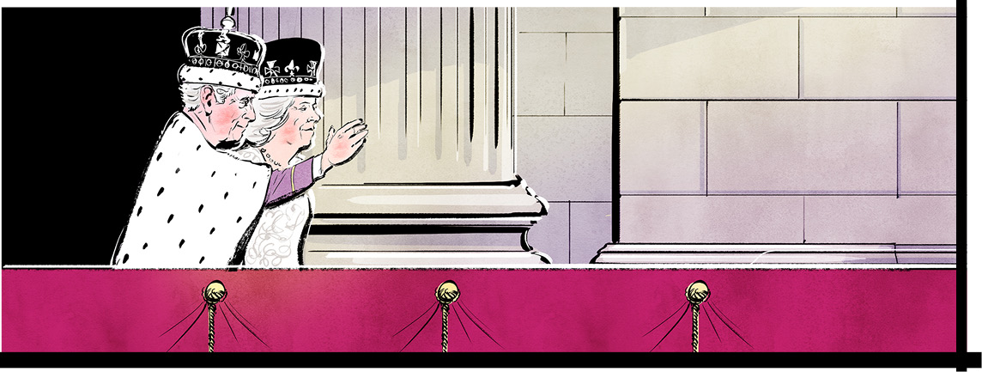

On Saturday, May 6, a dramatic ceremony took place in London’s historic Westminster Abbey. It drew hundreds of thousands of people from Britain and across the globe to the city. Millions more watched the event on TV.
A crowning moment
What caused all the excitement? The coronation of Charles III. The event formalized his role as king of the United Kingdom and 14 nations, including Canada. It was a moment of pomp, ritual, and 1000-year-old traditions.
Charles has in fact been king since last fall. He is the eldest son of Queen Elizabeth II. She died in September 2022. That made him heir to the throne. But the crowning took place after a time of mourning for Elizabeth, a very popular monarch who ruled for 70 years.
The coronation is a solemn rite. Experts say it uplifts and transforms a monarch in the eyes of the people.

A royal procession
Coronations are true spectacles. Officials spent months planning this one using a playbook dating back to the 11th century. The event began with a 2.3-kilometre procession from the king’s official residence, Buckingham Palace, to Westminster Abbey. The church is 754 years old. It has been the site of 39 coronations. William the Conqueror was the first king crowned there in 1066.
King Charles and his wife Camilla arrived at the church in a gilded coach pulled by six grey horses. Flanking them were 1000 members of the British military.
Nearly 30,000 police officers were stationed along the procession route and elsewhere. Monarchists and tourists lined the streets for hours – some camping out overnight – just to catch a glimpse of the couple.
The big event
At the church, 2000 invited guests celebrated. They included Prime Minister Justin Trudeau, other leaders, and celebrities. The Archbishop of Canterbury, head of the Church of England, conducted the ceremony. The assembly shouted “God Save the King” as trumpets blared. Next, Charles took an oath to uphold the law and to venerate the Church. The Archbishop anointed him with holy oil.
King Charles then took his place on the Coronation Chair. It was built in 1300 for his ancestor Edward 1. He held two golden scepters and the Royal Orb. This golden ball symbolizes his role as a Christian leader. At last, St. Edward’s Crown, weighing about 2.3 kilograms, was placed on his head. The 360-year-old gold relic has 444 bright gems.
Camilla was crowned with a headpiece worn by Queen Mary in 1911. Camilla's title is Queen Consort, the name given to the wife of a reigning monarch.
The two then returned to the palace in an 18th-century coach. Thousands of soldiers cheered. Across Britain, people celebrated. The Royals attended a concert in their honour featuring singer Katy Perry, and others. May 8 was declared a holiday, and citizens were encouraged to spend it volunteering.
The king's role today
Charles modernized his coronation in some ways. For example, Hindu, Sikh, Muslim and Jewish leaders played a big role in the event. That showed that he respects all faiths.
Another change? Charles' guest list, at 2000, was considered small. Britain's economy is doing poorly, so he wanted his event to be relatively modest. It still cost British taxpayers about $125 million, however. As well, for the first time ever, the public was invited to pledge allegiance to the king. Yet just 55 percent of Britons fully support the monarchy.
“[It] does seem an odd request when so many of us think that the monarchy is outdated,” said a Green Party member. “And I really think that the king is rich enough to pay for his own coronation.”
The big question: Can Charles make a 1000-year-old institution relevant in the 21st century?
That remains to be seen.

Of colonialism and the commonwealth
Aside from being king, Charles heads the Commonwealth of Nations, a 56-country organization. Today it supports the values of democracy, gender equality, sustainable development, peace, and security.
But critics of the Commonwealth see it as a relic of colonialism and the British Empire. That was a period starting in the 16th century when British influence expanded around the globe. Britain took raw materials from faraway territories, and controlled them with trade and shipping policies.
One of Britain’s most important colonies was India, which it ruled between 1858 and 1947. Indians today say the British looted their country, robbing it of priceless jewels and other goods. They are demanding that these items be returned. By one estimate, the British siphoned off $45 trillion from India over a period of 200 years.
Among the treasures Indians claim is theirs? The Koh-i-Noor diamond, a stone the size of an egg valued at $20 billion. The jewel was supposedly “gifted” to British Queen Victoria in 1849 by an Indian leader. It was placed in Queen Mary’s crown, but because of the controversy, Camilla replaced it with other gems..

anoint: to put oil or water on somebody’s head or body as part of a religious ceremony
Archbishop of Canterbury: the head of the Church of England, currently the Most Reverend Justin Welby
Church of England: also called the Anglican Church, the primary state church in England
colonialism: the practice by which a powerful country controls another country or territory
heir: a person who has the legal right to receive somebody’s property, money or title when that person dies
monarchist: a person who believes that a country should be ruled by a king or queen
pomp: the impressive clothes, decorations, music, etc. and traditional customs that are part of an official occasion or ceremony
rite: a ceremony performed by a particular group of people, often for religious purposes
scepter: a decorated rod carried by a king or queen at ceremonies as a symbol of their power
venerate: to have and show a lot of respect for something that is considered to be holy or very important

Comprehension Questions

1. What important event occurred in September 2022 that affected the United Kingdom?

2. When and where was King Charles III's coronation held?

3. Why was the coronation delayed for eight months?

4. What is the name of King Charles' official residence?

5. Describe the procession from the palace to Westminster Abbey.

6. Who performed the coronation ceremony?

7. Briefly describe at least two of the traditional objects that were part of the coronation ceremony.

8. How did King Charles try to modernize his coronation? Explain.

9. As king, what does Charles III lead beside the United Kingdom?

10. Why has support for the monarchy decreased over the years? Explain.

Questions for Further Thought

1. The article states that only 55 percent of British people fully support the monarchy and that 14 percent of under 35-year-olds don’t believe the monarchy is especially important. In addition, King Charles III's popularity has not kept up with that of his mother, Queen Elizabeth II. In your opinion, what actions could King Charles take to boost his likability? Give examples.

2. The article tells us that a number of changes were made to modernize and scale down the coronation, such as inviting fewer guests. Despite these changes, British taxpayers footed the $125-million bill for the ceremony, at a time when many of them are just getting by. As you see it, should the royal family pay for its own activities and events? Why or why not? Explain.

3. The article quotes Green Party member Baroness Jones of Moulsecoomb, who says, "Asking us to chant our allegiance does seem an odd request when so many of us think that the monarchy is an outdated institution that needs drastic reform." Do you agree or disagree with her statement? What kinds of reforms can you suggest that might make the monarchy more relevant? Give reasons to support your response.

Questions For Online Exploration
Note: The links below are listed at www.lesplan.com/links for easy access.

1. View the key moments in the ceremony:
The procession to Westminster Abbey: https://www.bbc.com/news/av/uk-65507470 [1:02]
The crowning of the King: https://www.cbc.ca/player/play/2203201603814 [0:42]
Prince William pledges his loyalty: https://www.cbc.ca/player/play/2203257923937 [0:29]
Camilla is crowned: https://www.cbc.ca/player/play/2203210819712 [0:38]
The procession to Buckingham Palace: https://www.bbc.com/news/av/uk-65511789 [1:03]
Waves from the balcony: https://www.cbc.ca/player/play/2203237955513 [0:58]
As you watch the ceremony, what questions come to mind?

2. Take a closer look at the coronation regalia and special clothing designed for this event:
https://www.theglobeandmail.com/canada/article-coronation-regalia-visual-guide/
https://www.bbc.com/news/av/uk-65231561 [1:22]
https://www.bbc.com/news/uk-65507923

3. Which countries are part of the Commonwealth of Nations and which recognize King Charles III as their sovereign?
https://www.bbc.com/news/uk-43715079

4. Not everyone feels favorably towards the British monarchy, given its history of colonialism and treatment of its colonies and their peoples. Learn more:
https://www.cbc.ca/player/play/2070815299734 [25:13] (podcast)
https://www.cbc.ca/player/play/1979285059726 [7:05]
What do you predict will be the future of the Commonwealth?

5. Will Canadian currency change now that King Charles III is the new monarch?
https://www.cbc.ca/player/play/2203301955885 [7:09] (podcast)
https://www.cbc.ca/news/canada/king-charles-image-money-1.6835006

Putting It All Together

A. Write the letter that corresponds to the best answer on the line beside each question:
______ 1. What event led to Charles becoming the new King?
a) Charles' marriage to Camilla b) his older sister stepped down from the throne
c) the death of Queen Elizabeth II d) a royal election
______ 2. Where was the new British king crowned?
a) Buckingham Palace b) Tower of London
c) Westminster Abbey d) Windsor Castle
______ 3. The Koh-i-Noor is an extremely valuable:
a) painting b) diamond
c) sculpture d) emerald
B. Mark the statements T (True) or F (False). If a statement is True, write one important fact to support it on the line below. If a statement is False, write the words that make it true on the line below.
______ 4. True or False? The coronation ceremony was conducted by the Archbishop of Canterbury

______ 5. True or False? King Charles III is the head of state of 56 countries.

______ 6. True or False? King Charles' coronation cost British taxpayers about $500 million.

C. Fill in the blanks to complete each sentence.
7. Someone who supports being ruled by a king or queen is called a _______________________ .
8. _______________________ Palace is King Charles' official residence.
9. Great Britain controlled and ruled _______________________ from 1858 to 1947.

D. Respond to the following question in paragraph form. (Use a separate sheet of paper if necessary.)
10. As you see it, was the significance of King Charles III's coronation ceremony? Give reasons to support your response.
Sudan On The Brink Of Disaster
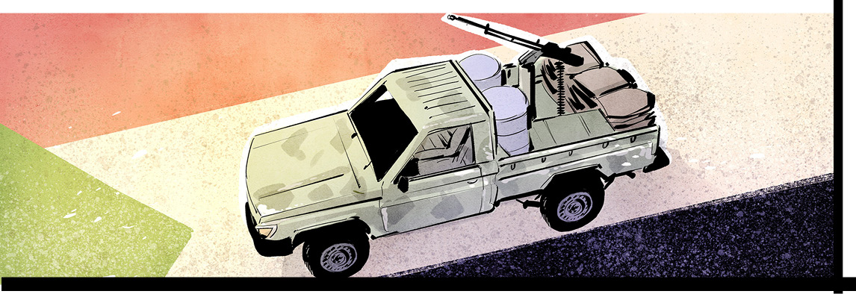

A catastrophe is playing out in the troubled country of Sudan. Competing generals and their soldiers are fighting for control of the government. By mid-May, at least 600 people had been killed in the conflict. Five thousand more had been wounded.
The fighting began April 15. Since then, more than 160,000 people have fled this African nation for Egypt, Chad, and elsewhere. Another 700,000 people have been displaced within the country.
The 5.2 million residents of Khartoum, the nation’s capital, are short of food, water, and electricity. Looters roam city streets, fighters have taken control of private homes, and hospitals have been shuttered, looted, or bombed, or are being used for military bases.
Coup after coup
The conflict has its roots in events four years ago. That’s when the government of then-president Omar al-Bashir was overthrown. Sudan's people were happy to see him go. Mr. al-Bashir, a cruel dictator, ruled for 30 years. He is now in a Sudanese jail and wanted by the international criminal court for genocide.
How was Mr. al-Bashir removed from power? In 2019, huge protests called for him to step down. People wanted the nation to transition to democracy. The country’s military, the Sudanese Armed Forces (SAF), took advantage of the unrest to oust the dictator. Its leader, General Abdel Fattah al-Burhan, became president. He agreed to form a civilian-military government and to hold elections in 2022. But the arrangement didn’t last long. The army blamed the civilian wing for Sudan’s struggling economy. It staged another coup in 2021.
There’s a more likely reason for the 2021 coup. Army leaders have a lot of economic power in Sudan. They control – and profit from – enterprises such as gold mining and military contracting. Democracy would bring this arrangement to an end.
A fight for power
In any event, infighting soon began between President al-Burhan and another leader of the 2021 coup. He is General Mohamed Hamdan Dagalo, better known as Hemedti. The two were one-time allies. They both once even supported former president al-Bashir. And they both played a key role in a vicious 16-year civil war that began in 2003 in the western region of Darfur. It mainly pitted Arabs against non-Arabs. Some 300,000 people died in that conflict; another two million were displaced.
During the Darfur war, General al-Burhan ran the army. General Dagalo commanded Arab militias called Janjaweed. The two men cooperated. They used brutal tactics to squash the rebellion of poorly-treated non-Arabs.
But now they disagree on how the country should be run. The big issue? General Dagalo is head of the Rapid Support Forces (RSF), a paramilitary organization. The RSF grew out of the Janjaweed. President al-Burhan wants the RSF to join the regular army under his control. That threatens Mr. Dagalo. The RSF has a big stake in Darfur's gold mines. If his forces become part of the regular army, he would likely have to give up control of the gold – and his fighters – to President al-Burhan.
Is there a way out?
The two groups are equally matched. General al-Burhan’s troops command the air and have more weapons. General Dagalo’s fighters are better on the ground. There's no clear path to ending the conflict, and observers fear fighting may widen into tribal warfare.
“Before the war started, both Hemedti and General Burhan [stoked] ethnic divisions,” said one expert.
Meanwhile, ordinary Sudanese are despairing. Millions already live in refugee camps. About one-quarter of the population barely has enough to eat. That has forced some terrible choices.
“We didn’t have food,” said a man trapped by the fighting for days. “[But] we preferred to die of hunger [than] by a bullet.”
Sadly, no one expects a quick resolution to end the fighting.
“They have had a year and a half after the coup where they failed to run the country. What sort of deal could these two men reach?” asked one analyst.

About Sudan
Sudan, located in northeast Africa, is about the size of Nunavut – nearly two million square kilometres. It is bordered by Egypt to the north, Eritrea and Ethiopia to the southeast, South Sudan to the south, Central South Africa to the southwest, Chad to the west, and Libya to the northwest. The Red Sea makes up much of its eastern border. Most of Sudan’s population of around 47 million is Muslim, with a small Christian minority. Arabic is the main language.
About 80 percent of Sudanese are farmers, growing crops such as peanuts, sorghum, millet, wheat, sugarcane, tapioca, mangos, bananas, sweet potatoes, and sesame. In 2021, Sudan’s main export was oil, which brought in $395 million (US), making the country the world's 54th largest exporter of this resource.
Because of ongoing political instability, Sudan is a very poor country. On average, people earn an annual income of just over $1000 (Canadian). Even before this crisis, nearly 16 million people needed humanitarian aid and about 3.7 million people were already internally displaced. According to the United Nations, more than 19 million people will be facing acute food insecurity this year as a result of this latest conflict.

Did You Know?
In 2011, South Sudan broke away from Sudan after over 20 years of guerrilla warfare. Some two million people are estimated to have died and four million displaced as a result of the war, and the famine and disease it caused.

civil war: a war between groups of people in the same country
coup: a sudden change of government that is often violent
genocide: the murder of a large number of people from a particular nation or ethnic group
international criminal court: the body that investigates and tries those charged with genocide, war crimes, crimes against humanity, and the crime of aggression
militia: a group of people who are not professional soldiers but who have had military training and can act as an army
paramilitary organization: an illegal group that is organized like an army

Comprehension Questions

1. What is the population of Sudan? How many Sudanese are farmers?

2. Describe this country's economy.

3. List at least three other important facts about Sudan.

4. Who was the leader of Sudan from 1989 until 2019?

5. Where is he now?

6. Explain how and why he ended up there.

7. Name the new leader of Sudan who took over in 2019.

8. Explain who the Rapid Support Forces are. Who is the leader of this armed group?

9. When did the recent fighting start in Sudan? How have people been affected?

10. What was the reason for the outbreak of violence?

Questions For Further Thought

1. Before this conflict, President al-Burhan and General Dagalo worked together as allies to oust Sudan’s former leader, President al-Bashir, from office. As you see it, how might the former relationship and cooperation between these two men influence their choices and actions as rivals during this civil war? Support your ideas with examples.

2. The article describes the terrible living conditions for many Sudanese citizens during this dangerous conflict. As you see it, what is the role of the international community in supporting Sudan and its citizens during this devastating civil war? Explain.

Questions For Online Exploration
Note: The links below are listed at www.lesplan.com/links for easy access.

1. Learn more about the situation in Sudan and the failed attempts at securing a ceasefire to get help to innocent civilians:
https://www.yout-ube.com/watch?v=GSkWmYfXFYI [4:58]
https://www.cbc.ca/player/play/2201443907994 [2:06]
https://www.cbc.ca/player/play/2202531395940 [2:07]
What did you learn?

2. Learn about the Canadian connection to Sudan and its efforts to evacuate Sudanese Canadians and Canadian nationals from the country:
https://www.cbc.ca/player/play/2204153411552 [19:32] (podcast)
https://www.cbc.ca/news/world/sudan-canada-evacuation-flights-1.6827327 [2:25]
https://www.cbc.ca/player/play/2198807619662 [3:06]
https://www.cbc.ca/player/play/2197833795710 [2:03]
https://www.cbc.ca/news/world/sudan-conflict-exodus-1.6828034 [2:06]
https://www.cbc.ca/news/politics/sudan-civil-war-evacuation-1.6833712
Do you feel that Canada is doing enough to provide assistance during this conflict? Explain.

3. How has the United Nations responded to this conflict?
https://news.un.org/en/story/2023/04/1135857

4. Discover how this conflict might impact the international community:
https://www.yout-ube.com/watch?v=gJ4lNyb-Pbg [2:38]

Putting It All Together

A. Write the letter that corresponds to the best answer on the line beside each question:
______ 1. What is the population of Sudan?
a) 5 million b) 55 million
c) 33 million d) 47 million
______ 2. What is the capital of Sudan?
a) Darfur b) Cairo
c) Khartoum d) Tripoli
______ 3. A war between two or more groups inside one country is called a:
a) civil war b) proxy war
c) counter attack d) guerilla war
B. Mark the statements T (True) or F (False). If a statement is True, write one important fact to support it on the line below. If a statement is False, write the words that make it true on the line below.
______ 4. True or False? Sudan is one of the poorest countries in the world.

______ 5. True or False? Christianity is the largest religion in Sudan.

______ 6. True or False? The current leader of Sudan is General Abdel Fattah al-Burhan.

C. Fill in the blanks to complete each sentence.
7. A sudden, violent change of government is called a _______________________ .
8. The Arab militia fighters who fought in Darfur were called _______________________ .
9. General Dagalo is the head of the _______________________ Support Forces.

D. Respond to the following question in paragraph form. (Use a separate sheet of paper if necessary.)
10. What is your understanding of the reasons for the outbreak of violence in Sudan? Explain.
The Gift of Life
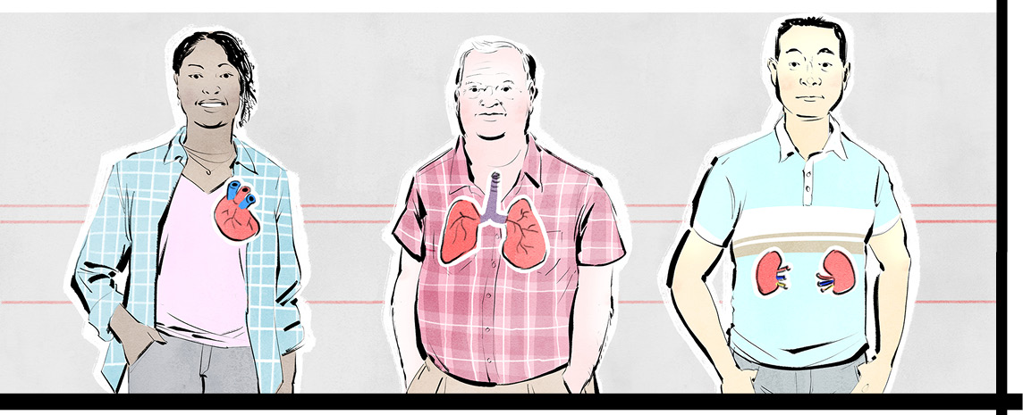

Brandy Hehn of Regina, Saskatchewan, is alive today because people donated their organs. She is a two-time organ transplant recipient.
As a teenager, Ms. Hehn was diagnosed with a rare liver disease. In 2009, she received a liver transplant from a deceased donor. Then, her kidneys failed. She went on dialysis; that bought her some time. A dialysis machine removes toxins from the body when kidneys can’t.
“Dialysis is zero, zero, zero fun,” says Ms. Hehn.
She was put on the transplant list for a kidney in 2020. As a former liver recipient, she was not sure she would be lucky enough to get a second donation. But she waited only a few months.
She believes it was the “Logan Boulet Effect” that helped her get a kidney in such a short time.
A tragic event
Five years ago the Humboldt Broncos bus crash shocked Canada. The Broncos are a Junior hockey team from Saskatchewan. On April 6, 2018, the team was going to a playoff game when a truck hit their bus. Thirteen passengers survived; sixteen died. One of the dead was twenty-one-year-old defenseman Logan Boulet.
Just weeks before the crash, Logan had signed his organ donor card. He had been inspired by his coach, Ric Suggit, an organ donor who died in 2017. Mr. Suggit's death saved lives. Logan wanted to do the same.
So on April 7, Logan’s heart, lungs, liver, kidneys, pancreas, and corneas were donated. Officials later told his family that all the transplants were successful.
Inspired to give
Logan’s generosity is a big part of the story of the tragic bus crash. Word spread across Canada. In the weeks following the accident, almost 150,000 people registered to become organ donors.
Today, the “Logan Boulet Effect” is still inspiring Canadians to sign up. Logan’s parents, Toby and Bernadine Boulet, travel widely, sharing his story, hoping others will give the gift of life.
“We still get people who tell us, ‘I registered because of Logan’s story,’” Bernadine said.
Logan’s father, Toby, calls the “Logan Boulet Effect” movement a silver medal – the best thing to come out of their worst loss.
An ever-present need
Every April 7, Canada celebrates Green Shirt Day in Logan’s honour. Green is the official colour of organ and tissue donation. It represents the hope donors provide to patients in need. As it happens, April is also Donor Awareness Month.
In 2021, 2782 Canadian received transplants. More than 4000 are on a wait list. About 250 die each year before a lifesaving organ is found. A poll showed that 84 percent of Canadians favour the donation of human organs and tissue after death. Yet only 68 percent said they would donate their own. At present, less than one-quarter of Canadians are registered organ donors.
Steps to a transplant
Provinces differ, but becoming a donor usually involves filling out a form, on paper or online. (Except in Nova Scotia. By law, anyone living there for a year or more is automatically a potential donor after death. People can opt out, however.)
Even if they register, most people won’t become organ donors. Less than two percent of people die in a way that allows their organs to be transplanted.
Generally, donors have suffered an injury leading to brain death. A person who is brain dead has lost all brain function. The person has died even though the heart keeps beating and a machine maintains breathing.
Blood can still flow to other organs after brain death. So if the organs are healthy, they can be transplanted. The heart, liver, kidneys, lungs, pancreas, small intestine, eyes, bone, skin, and heart valves can all be donated. One donor can save up to eight lives and help 75 people or more.
Recipients are matched to organs based on blood type, height, and weight. Those most in need or who have been waiting longest get priority. Recipients who get a call race to a transplant centre because every second counts. Meanwhile, surgeons remove and package the donor organs for delivery to the centre. Once an organ arrives, the transplant team puts it into the patient, attaching it to arteries or veins so that blood can start flowing through it.
Recipients are on anti-rejection drugs for life. Rejection is the body’s normal reaction to a foreign object or tissue. The immune system thinks the new organ is a threat and attacks it. Anti-rejection meds trick the immune system into accepting the transplant.
A patient’s transformation can be remarkable. Before a transplant, someone can be on complete life support “with wires hanging inside and out of them,” says James Breckenridge of the Canadian Transplant Association. Within a week, they are often walking and healthy.
“It’s amazing to see," he says.
Using her skills
Brandy Hehn once found it hard to talk about her transplants. Her illness is a painful memory. But gratitude has brought her forward.
Ms. Hehn is a designer. She wanted to find a way to thank Logan’s parents for promoting organ donation. So, she designed the 2023 Green Shirt Day logo. The logo has two hockey sticks. They symbolize the sticks that people put on porches after the Humboldt crash. The logo also has 29 stars, honouring everyone on the Broncos bus – those who died and those who lived. It also has calls to action: “Register” and "Tell your family.”
“My hope is that people will see this design, wear the shirt and spread awareness about Green Shirt Day, the #LoganBouletEffect and what the Boulets continue to do for all of us needing an organ transplant.”

Did you know?
Living donations are also possible. One kidney, or part of a liver, lung, small bowel, or pancreas can be donated.
A kidney or part of a liver are the most common living donations.

Comprehension Questions
Comprehension Questions

1. Which two living organ donor donations are the most common?

2. List at least four other organs that can be transplanted.

3. How many transplants were performed in Canada in 2021?

4. Where do the Humboldt Broncos play hockey?

5. What tragic event did this team experience five years ago?

6. Who was Logan Boulet?

7. Describe the how Logan Boulet became an organ donor. Who inspired him to do this?

8. What is the "Logan Boulet Effect"? Explain why it is still continuing.

9. When is Green Shirt Day?

10. What is the purpose of this special day? What colour is associated with this day? Explain.
.

Questions For Further Thought

1. The article tells us the organ transplant story of Brandy Hehn and the components of her 2023 Green Shirt Day logo design. As you see it, how has Green Shirt Day impacted the lives of Ms. Hehn and other organ recipients and their families? Support your ideas with examples.

2. The province of Nova Scotia has a 'presumed consent' model of organ donation. This means that a person who has lived there for at least a year, and who dies, is presumed to be an organ donor unless they've opted out of this consent. Do you agree or disagree with this model? Give reasons to support your response.

3. A 2022 poll found that 84 percent of Canadians are in favour of organ and tissue donation. Yet according to the federal government, less than one quarter of Canadians are registered organ donors. As you see it, why might Canadians be hesitant to register for organ donation despite being supportive of it? Give reasons to support your response.

Questions For On Line Exploration
Note: The links below are listed at www.lesplan.com/links for easy access.

1. Learn more about organ donor Logan Boulet and how his parents are honouring his legacy:
https://www.cbc.ca/news/canada/calgary/humboldt-broncos-organ-donation-increase-1.4612143
https://www.cbc.ca/news/canada/manitoba/bronco-defenceman-organ-heartbeat-1.5976702
What did you learn?

2. Discover how Green Shirt Day was established and how it has inspired the "Logan Boulet Effect":
https://www.cbc.ca/news/canada/saskatchewan/loganbouleteffect-and-green-shirt-day-still-inspire-organ-donors-5-years-after-bus-crash-1.6804507
http://www.cbc.ca/player/play/1481041987835 [2:08]
https://greenshirtday.ca/
What questions do you have?

3. Visit the Canadian Transplant Association and check out the ambassador tool kits for Green Shirt Day:
https://www.canadiantransplant.com/green-shirt-day

4. Hear from doctors and families why we should consider organ donation:
https://www.cbc.ca/player/play/2020297795989 [44:57] (podcast)
https://www.cbc.ca/player/play/2197544515597 [6:51] (podcast)
https://www.cbc.ca/player/play/2198622787675 [8:09] (podcast)
What impressions do you take away from these discussions?

5. What does the federal government say about organ donation across Canada?
https://www.canada.ca/en/health-canada/services/healthy-living/blood-organ-tissue-donation/organ-tissue.html

Putting It All Together

A. Write the letter that corresponds to the best answer on the line beside each question:
______ 1. Which hockey team did Logan Boulet play for?
a) Pittsburgh Penguins b) Saskatoon Blades
c) Red Deer Rebels d) Humboldt Broncos
______ 2. What does Canada celebrate on April 7 each year?
a) Give Blood Day b) the Logan Boulet Effect
c) Green Shirt Day d) Hockey Day in Canada
______ 3. Which province has adopted a ‘presumed consent’ organ donation policy?
a) Alberta b) British Columbia
c) Nova Scotia d) Saskatchewan

B. Mark the statements T (True) or F (False). If a statement is True, write one important fact to support it on the line below. If a statement is False, write the words that make it true on the line below.
______ 4. True or False? Logan Boulet's parents continue to promote transplant awareness.

______ 5. True or False? One donor's organs can save up to eight lives and benefit over 75 people.

______ 6. True or False? Transplant recipients must take anti-rejection drugs for ten years.

C. Fill in the blanks to complete each sentence.
7. A _______________________ machine removes toxins from the body when the kidneys cannot.
8. Anti-rejection drugs trick the recipient's _______________________ system to accept the transplant.
9. The official colour of organ and tissue donation is _______________________ .

D. Respond to the following question in paragraph form. (Use a separate sheet of paper if necessary.)
10. Describe how an organ transplant works. What are the main steps and key details of the process?

Assessment Rubric

This rubric may be helpful in providing students with formative, strength-based feedback and/or assessing students’ responses holistically. This easy-to-modify activity is included in the doc file which you can download from:
www.lesplan.com/subscribers

 | Emerging | Developing | Proficient | Extending
Supports thinking | Answers or reflections are brief and include obvious facts/details/ evidence. | Answers or reflections are general and supported with some relevant facts/details/evidence. | Answers or reflections are clearly supported with specific, relevant facts/details/evidence. | Answers or reflections are insightful and supported with specific, relevant facts/details/evidence.
Shows understanding | Responses show a basic understanding of the text, topic, issue or message. | Responses are thoughtful and show a general understanding of the text, topic, issue or message. | Responses are thoughtful and show a complete understanding of the text, topic, issue or message. | Responses are insightful and show a deep understanding the text, topic, issue or message. May synthesize ideas or explain the ‘so what’.
Thinks  critically | Makes straightforward connections or inferences. Focuses on retelling. | Makes logical connections to self (T:S) and/or background knowledge (T:S). Inferences are logical | Makes meaningful connections to self. Considers ideas between texts (T:T).  Inferences are plausible. | Makes powerful connections that go between texts and/or beyond the text (T:W).  Inferences are plausible and insightful.

