Articles and Questions
Each issue of The Canadian Reader includes:
1) a PDF file (the complete document) and
2) a Word file that contains only the articles and questions. This file does not contain an Answer Key.
This Word file allows students to complete assignments using a computer either at school or at home. Teachers can assign all or parts of the file by email attachment or a school website. The Word file also allows teachers to:
• easily modify and format content including changing fonts and text sizes
• create a PDF document and use Adobe Reader's 'Read Out Loud Mode'
• save paper and copying costs and help protect the environment
• promote and encourage students’ computer skills

Access Data
There are two main ways to access the data in this Word file:
1) Open the Word file and select the data you wish to Copy. Then Paste the data it into any word processing or email program. Use Select All to copy the entire document.
2) Most word processing programs will open Word files. You can use LibreOffice or Open Office (or another similar free program) to open and save .docx Word files.
See: www.libreoffice.org/discover/libreoffice/ www.openoffice.org

What Else Can You Do With The Word File?
#1) You can easily upload the file to Google Drive and share it with students or other teachers. See how here:
https://support.google.com/drive/answer/2424368?hl=en
#2) Translate the uploaded document into another language. (see Tools>Translate document). Google Docs will create a new copy of the original file but you will need to edit the document to suit your requirements. Google Docs can translate into over 100 languages including Spanish, Mandarin, German, etc. See how here:
https://support.google.com/docs/answer/187189?hl=en&co=GENIE.Platform=Desktop

A King is Crowned
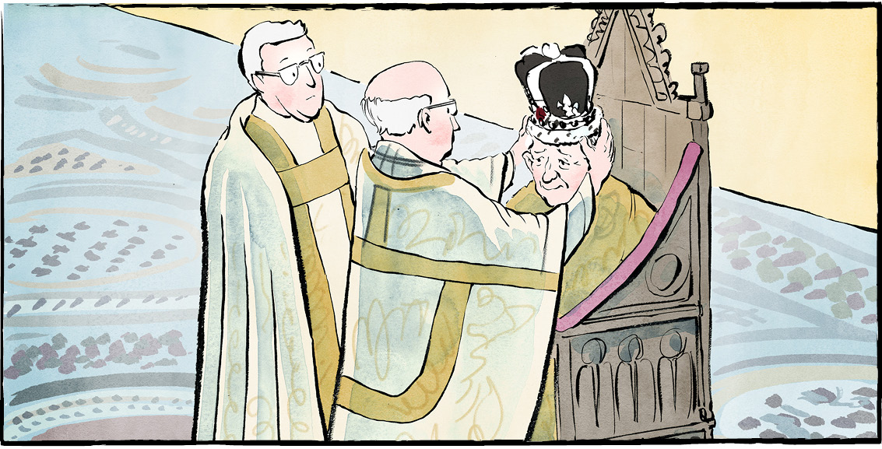

On May 6, 2023, Charles III was crowned. He is King of the United Kingdom of Great Britain and Northern Ireland.
Charles’ coronation was held in London, England. It took place in Westminster Abbey. Charles is the 40th king or queen to be crowned there since 1066.
Traditional ceremony
The ceremony lasted almost two hours. It honoured many traditions.
For example, Charles sat in the 700-year-old “Coronation chair” during the ceremony. The crown placed on his head was made in 1661. With its solid gold frame, it weighs over two kilograms. This crown is only worn at coronations.
Charles vowed to uphold the law and the Church of England. He swore to govern with “justice and mercy.”
Modern touches
However, some parts of the ceremony were updated for today’s world. The last coronation was more than 70 years ago!
For the first time, female bishops were included. There were roles for people of different religions, too. The Buddhist, Hindu, Jewish, Muslim, and Sikh faiths were all represented.
The only person to kneel and swear loyalty was Prince William. He is Charles’ heir. Everyone else was asked to repeat a vow, instead.
More than 2200 people from 203 countries filled the abbey. Large crowds lined the streets. In the UK, about 18 million viewers watched on television.
King of Canada
Canada is a constitutional monarchy. The king is our Head of State. That means Charles is King of Canada.
Prime Minister Justin Trudeau attended the coronation. Canada’s governor general, Mary Simon, was there as well. She represents the king in Canada.
After the ceremony, there was a march. Members of the RCMP and Canadian Armed Forces took part.
Across Canada, people woke up early to watch the coronation. In Ottawa, a smaller ceremony was held.
Low support for royals
Not everyone was excited, however. A recent study asked Canadians how they feel about the royals. Fifty-six percent said we should “reconsider” our ties with them.
In London, there were protests over the coronation. The ceremony cost about $170 million in Canadian dollars. It was paid for by British taxpayers.
Also, the Royal Family’s history cannot be ignored. Some of their wealth came from colonization and the slave trade.
What to expect
A new Canadian stamp has King Charles III on it. The king's profile will appear on our coins and on the $20 bill. But other than that, not much will change in Canada. Charles’ role here is mostly symbolic.
Symbols can matter, though. What do we know about King Charles III? For one thing, he cares about the environment. He also wants people to listen to Indigenous voices.
King Charles’ reign may be like his coronation. We may see a mix of the old and the new.

When someone is crowned, it’s called a coronation.

As you see it, what is the importance of the king's coronation?

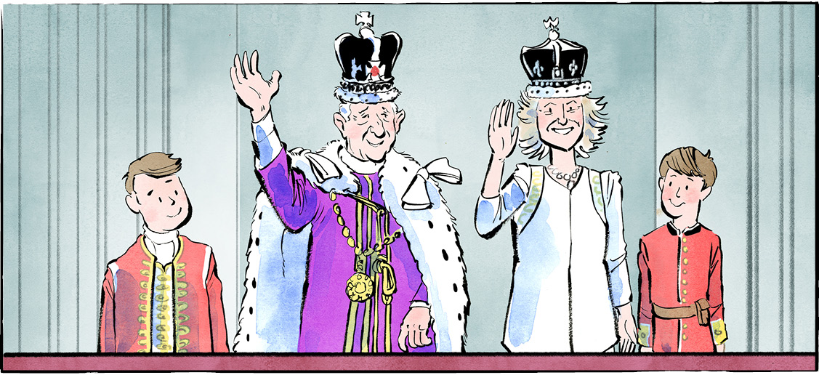

Comprehension Check
Mark the statements T (True) or F (False). If a statement is true, write one fact to support it on the lines below. If a statement is false, write the word or words that make it true on the lines below.

1. The coronation was held in London, England.

2. The last coronation was more than 70 years ago.

3. Female bishops were included for the very first time.

4. Queen Camilla was the only person to kneel and swear loyalty.

5. Everyone was excited for the coronation.

6. King Charles III’s profile will soon appear on our coins and the $20 bill.

Language Focus
A pronoun is a word that takes the place of a noun. There are three types of pronouns: subject (I, he, she, it, you, etc.); object (me, him, her, you, etc.); or possessive (mine, his, hers, theirs, yours, etc.)

Directions: Circle the pronouns.
1. Give the book to the girl; it belongs to her and she really likes it!
2. The dog watched the boy because he had a ball.
3. The hat fits you, but it is too small for him!
4. I want to be away from them and the noise they are making.

Directions: Fill in the blanks using the pronouns below.
1. The crown placed on head was made in 1661.
2. Prince William was there. is Charles’ heir.
3. Would you like to watch the coronation at my place or ?
4. The ceremony lasted almost two hours. honoured many traditions.
his he yours it

Can you find more examples of pronouns in the article?
Write the sentences and circle the pronouns.
Returning to the Ocean
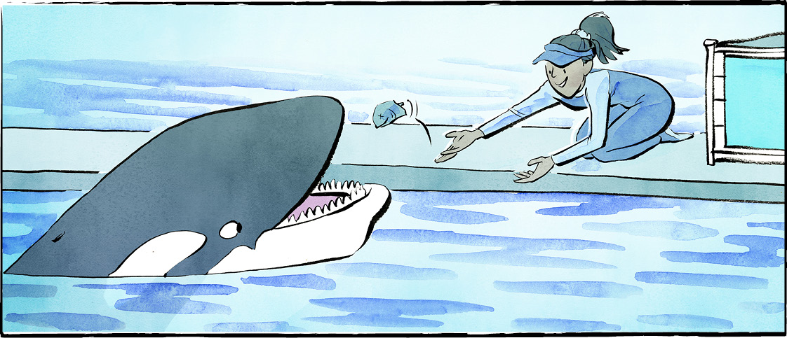

Lolita the orca lived with her pod in the ocean. In 1970, she was captured. She was only four years old. That was the last time she saw her home.
For more than 50 years, she has lived at the Miami Seaquarium. She entertained crowds. She depended on handlers.
Now, there are plans to return Lolita to her ocean home.
Lolita is one of the oldest orcas in captivity. She is also the only Southern Resident Killer Whale not living in the wild.
A need for space
Lolita’s Florida tank is 24 metres long, 11 metres wide, and only 6 metres deep. It is the smallest orca tank in the United States.
Lolita is about six metres long. She needs more space. Orcas in the wild swim about 160 kilometres per day, says Raynell Morris. Ms. Morris is an Elder of the Lummi Tribe in Washington State.
The Southern Resident Killer Whales live in the Salish Sea near British Columbia and Washington. They are endangered. They are also important to the Lummi people.
Ms. Morris serves on the board of Friends of Toki. The non-profit group is working to have Lolita set free.
Improper care
Lolita’s tank size is not the only problem. The tank provides no shelter from the hot Florida sun. The sun has damaged the orca's eyes.
Lolita has not always been treated well. A 2021 report said the orca was fed rotten fish that made her sick. It said her trainers ignored advice from her veterinarian. There were other problems, too.
Meant to live wild
The first wild orca was captured in 1961. Since that time, we have learned more about these mammals. They are intelligent and social. They have close family bonds.
In the wild, female orcas can live as long as humans. But in tanks, their lives are shorter.

Ongoing care
Now, the aquarium has new owners. They want to help Lolita return to the ocean.
At first, she will live in a large netted area in the water. Her new territory will be about as big as two football fields.
People will care for her and feed her while she adapts. Trainers and veterinarians will teach her how to fish. That work has already started.
Charles Vinick is one of her trainers. He thinks the ocean will be good for her. In the ocean, “she can chase crabs and birds and feel the waves and the current and the weather,” he says.
She will also be able to communicate with her pod. The orca believed to be her mother is still alive!
A happy reunion?
Some experts do not support the plan to move Lolita. She is no longer young and has health problems. She may not be accepted by her pod.
Still, Ms. Morris has confidence in Lolita—or Toki, as she calls her. “She was four when she was taken, so she was learning how to hunt,” she says. “She knows her family song. She’ll remember, but it will take time.”

As you see it, should Lolita be moved? Why or why not?
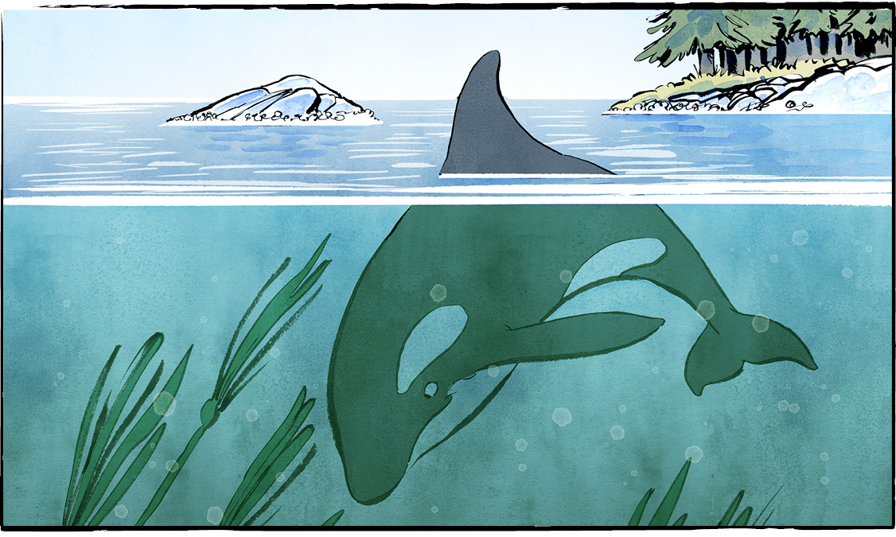
Lolita is also known as Tokitae, or Toki. Tokitae is a greeting the Coast Salish people use. It means ‘nice day, pretty colours.’

Comprehension Check

Answer the questions below in complete sentences:

1. Where did Lolita live for more than 50 years?

2. Why does Lolita need more space?

3. Describe Lolita’s tank.

4. What is Friends of Toki?

5. What have we learned about orcas since 1961?

6. Why do some experts not support the plan to move Lolita?

Language Focus

Proper nouns name specific people, places and things. They begin with a capital letter.
Can you find the proper nouns in the article? Write them in the appropriate circles below.

Places

Things

People

To the Moon and Back
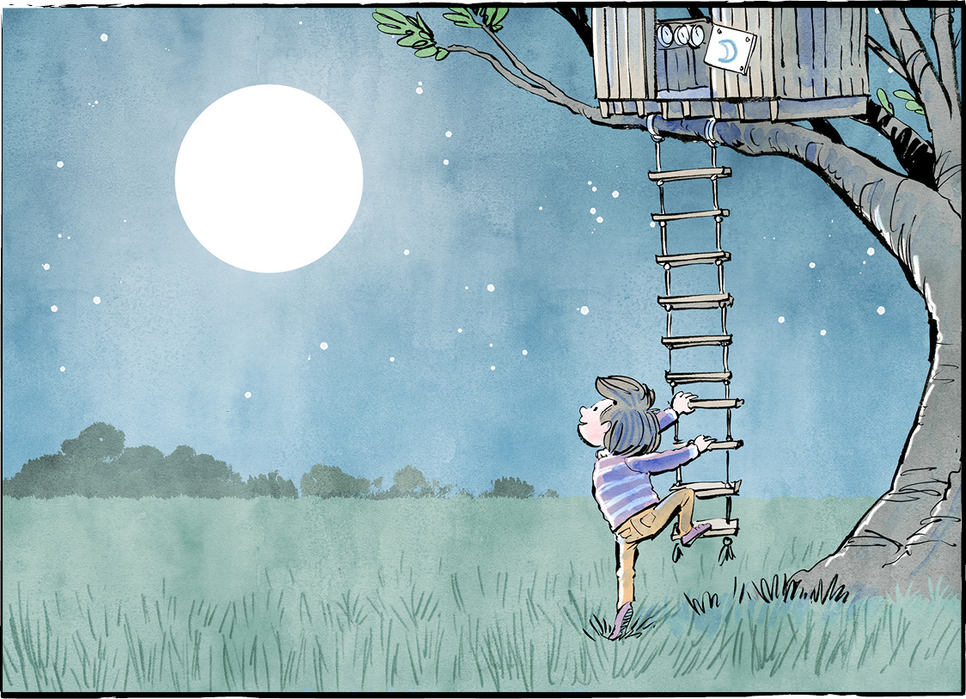

Jeremy Hansen grew up on a farm near London, Ontario. As a kid, he loved airplanes. One day, he saw a picture of astronaut Neil Armstrong. A man, standing on the Moon! Jeremy turned his treehouse into a rocket ship. He started dreaming of space.
A mission of firsts
Fast forward to 2023. Jeremy Hansen is a Canadian astronaut. He’s been given the chance of a lifetime. He will go to space! Mr. Hansen will join the Artemis II crew as a Mission Specialist. His three crewmates are astronauts from NASA.
Their mission is to fly a figure-8 around the Moon in November 2024. The trip will take ten days. During that time, the crew will cover more distance than any astronauts before them.
It’s a mission of firsts in other ways, too. Mr. Hansen will be the first Canadian to leave low-Earth orbit. He will also be the first Canadian on a lunar mission.
Victor Glover is the pilot. He will be the first person of colour on a lunar mission. Christina Koch, a Mission Specialist like Mr. Hansen, will be the first woman.
An incredible journey
The Artemis program is teaching us about Moon travel, one mission at a time.
Artemis I orbited the Moon with no humans on board. Artemis III, planned for 2025, will land astronauts on the Moon. The Artemis II crew will carry out tests while in orbit around the Moon. The results will help the Artemis III mission.
The journey will include incredible moments. Mr. Hansen looks forward to seeing an Earthrise. That’s when Earth is visible as a circle, seen from space.
The astronauts will also see the dark side of the Moon. The region beyond that is deep space. The Artemis II astronauts will be the first humans to go there.
Canadian pride
Mr. Hansen is excited to be part of the program. He’s happy for himself and proud of Canada. He hopes Canadians feel proud, too.
Canada earned its seat on the Artemis II mission. We have done great work for the space program.
NASA is building a space station to orbit the Moon. It will be called the Lunar Gateway. Canadian engineering will play a big role. The “Canadarm3” is a robotic space arm. Two arms, actually—a big one and a small one. The arm uses artificial intelligence. It will take care of the Lunar Gateway when no one is on board. That includes fixing problems and keeping science experiments going.
“We are up to big things here in Canada,” Mr. Hansen says. We can do things that seem impossible. All we have to do is believe in ourselves.
Just ask that little boy, looking up at the Moon.

What questions would you like to ask Jeremy Hansen?

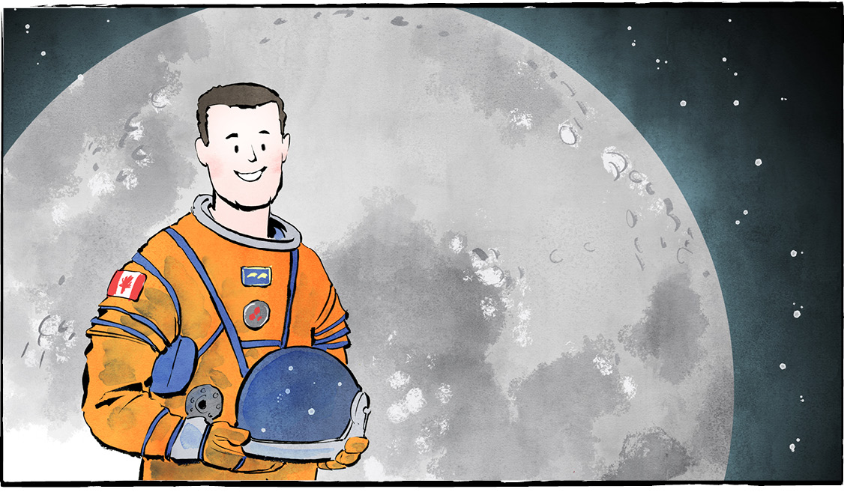

Comprehension Check

Write the letter of the best answer in the space beside each question.

1. What did Jeremy Hansen love as a kid?
a) Astronauts. . b) Airplanes.
c) Treehouses. d) The Moon.
2. What is the Artemis II crew’s mission?
a) Fly a figure-8 around the Moon.
b) Land on the Moon.
c) Go into space.
d) Test a new rocket.
3. Who is the pilot of Artemis II?
a) Christina Koch. b) Jeremy Hansen.
c) Victor Glover. d) Neil Armstrong.
4. The Artemis II astronauts will be the first humans to go where?
a) Deep space. b) The Moon.
c) A space station. d) Into orbit.
5. What is the Canadarm3?
a) A lunar mission.
b) A science experiment.
c) A space station.
d) A robotic space arm.

Language Focus

Connect the words with their definition.

a person who serves aboard a spacecraft | pilot
the amount of space between two things | mission
the amount of space between two things | orbit
a person who operates an airplane | journey
the path around a planet or a moon | impossible
a trip | incredible
not able to occur | distance
difficult to believe | astronaut

Now use three of these words in your own sentences.
1.
2.
3.

