Articles and Questions

Each issue of ***The Canadian Reader*** includes:   
  
1) a PDF file (the complete document) **and**

2) a Word file that contains **only** the articles and questions. This file does **not** contain an Answer Key.

This **Word** file allows students to complete assignments using a computer either at school or at home. Teachers can assign all or parts of the file by email attachment or a school website. The **Word** file also allows teachers to:

• easily modify and format content including changing fonts and text sizes

• create a PDF document and use Adobe Reader's 'Read Out Loud Mode'

• save paper and copying costs and help protect the environment

• promote and encourage students’ computer skills

Access Data

There are two main ways to access the data in this Word file:

1) Open the **Word** file and select the data you wish to **Copy.** Then **Paste** the data it into any word processing or email program. Use **Select All** to copy the entire document.

2) Most word processing programs will open **Word** files. You can use **LibreOffice** or **Open Office** (or another similar free program) to open and save **.docx** Word files.

See: [www.libreoffice.org/discover/libreoffice/](http://www.libreoffice.org/discover/libreoffice/) [www.openoffice.org](http://www.openoffice.org)

What Else Can You Do With The Word File?

#1) You can easily upload the file to Google Drive and share it with students or other teachers. **See how here:**

<https://support.google.com/drive/answer/2424368?hl=en>

#2) Translate the uploaded document into another language. (see **Tools>Translate document**).Google Docs will create a new copy of the original file but you will need to edit the document to suit your requirements. Google Docs can translate into over 100 languages including Spanish, Mandarin, German, etc. **See how here:**

<https://support.google.com/docs/answer/187189?hl=en&co=GENIE.Platform=Desktop>

Daylighting Rivers

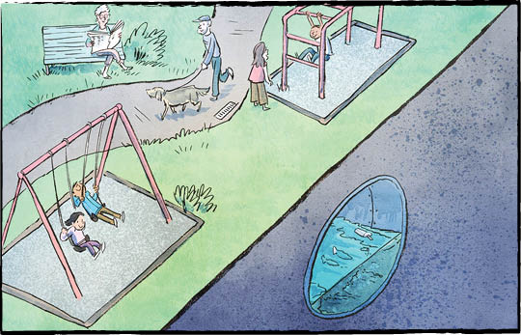

Look down. There may be a river beneath your feet! Just kidding. You won’t be able to see it. But that doesn’t mean it’s not there.

In some of Canada’s biggest cities, rivers run underground. They flow through pipes and concrete tunnels.

**A solution to pollution**

The rivers were buried so people could have more land to build on. There were other reasons, too.

In the 1800s, many rivers were polluted. There was no safe system for treating human waste. The rivers filled with sewage. They spread diseases like cholera and typhoid.

City planners came up with a solution. They moved the rivers and streams into underground tunnels.

**What we missed**

Moving the rivers underground caused other problems.

Rivers, streams, and creeks help control flooding. They give stormwater somewhere to go. Riverbanks absorb water slowly. Pipes can’t do that. They hold only so much water, then they overflow or burst.

Waterways and green spaces have other benefits, too. They help keep cities cool. They provide habitat for wildlife. They are also good for people’s mental health.

Cities around the world are returning  
rivers to the surface. This is called  
“daylighting.”

**A buried school brook**

Havergal College is a private girls’ school in Toronto. Burke Brook ran through its grounds.

Decades ago, the brook was buried. It was trapped in a pipe at the bottom of a ravine.

In 2013, the school wanted to build an outdoor learning space. An architect studied the land. He said that Burke Brook would need to be daylighted. The school agreed.

Now, students help care for the natural space. They learn from it, too.

The students have removed invasive plants. They replanted the area with native species.

Dogwood and ferns support the creek’s banks. They also absorb rainwater.

Last year, students planted trees to help control erosion. Logs and branches in the stream slow the water’s flow. They create  
a natural filtering system.

Burke Brook brings nature to a school in  
the city.

**Many challenges**

Sometimes daylighting is not possible. Streets and houses may have been built where the river would go. Some underground rivers are mixed with sewage tunnels. Daylighting them would be a big job. The sewage needs to be kept separate.

But where they can, cities are trying to bring back rivers.

The island of Montréal has lost about 82 percent of its waterways.

What if… cities did not want to bring back rivers?

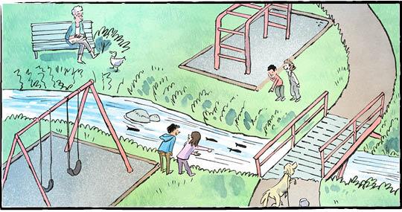

**Comprehension Check**

Write the letter of the *best* answer in the space beside each question.

**1. Why were the rivers buried?**

a) Concrete tunnels were easy to build.  
 b) Increased population.  
 c) To reverse pollution.  
 d) So people could have more land to build on.

**2. What is “daylighting” ?**

a) Treating water during the day.  
 b) Returning rivers to the surface.  
 c) Providing habitat for wildlife.  
 d) Building outdoor learning spaces.

**3. What did the Havergal College students do to help control erosion?**

a) They planted trees.  
 b) They dug up pipes.  
 c) They removed concrete.  
 d) They built an outdoor learning space.

**4. Why is it not always possible to daylight rivers?**

a) It takes a long time.  
 b) Cities do not want to bring back rivers.  
 c) The underground rivers are hard to find.  
 d) Some streets and houses are built where the river would go.

**Language Focus**

Prefixes are added to the beginning of a word. They change a word's meaning.

*Example*: **un** + **done** = **undone**

**Directions**: Add a prefix from the bottom of the page to each of the words below. Then, write a sentence to show that you know the meaning of each new word.

1. ___**patient:**
2. ___**certain:**
3. ___**place:**
4. ___**respectful:**
5. ___**reversible:**

**dis un**

**im re**

**ir**

Which words from the article contain RE prefixes?

So Long, Brave Little Hunter

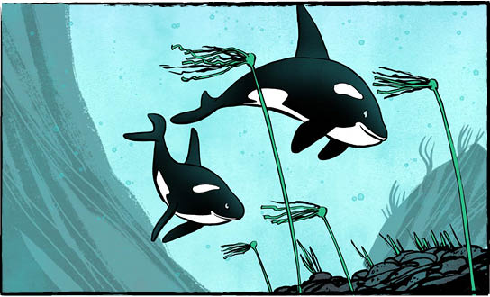

It was a heart-breaking story. An orca calf, just two years old, motherless and alone. She was trapped in a tidal lagoon, unable to swim out to sea. The plight of “Brave Little Hunter” made headlines around the world.

**How the saga began**

On March 23, an orca mother and her baby were hunting. They were swimming off northwestern Vancouver Island. The whales swam up an inlet and into a tidal lagoon — a shallow bay. When the tide went out, it became even shallower.

Tragically, the mother became stranded on a rocky beach. Residents of the local community of Zeballos sprang into action. They tried frantically to free her. In spite of these efforts, the whale died.

The baby orca was alone. She wasn’t old enough to survive on her own. She would need to head out to sea to find her family.

The problem? Her way out of the lagoon was blocked by a sandbar. Even at high tide, the young whale wouldn’t swim over it.

**To the rescue**

The nearby **Ehattesaht** First Nations community gave the young orca a name. It is kʷiisaḥiʔis (pronounced kwee-sa-hay-is) or Brave Little Hunter.

Along with whale experts and veterinarians, First Nations members monitored the orca. She seemed to be healthy and swimming well. They fed her some seal meat.

They also tried to get Brave Little Hunter out of the lagoon. They tried luring her with meat, whale calls, and violin music. They tried catching her in a sling and airlifting her using a helicopter. They tried herding her with boats. But nothing worked.

**Free at last!**

The calf stayed in the lagoon for about a month. Then, on a calm, starlit night, Brave Little Hunter crossed over the sandbar at high tide and out into the open ocean. She did it all by herself. Only a few local residents saw her leave.

Once in deeper waters, her behaviour seemed to change. She sped away.

“It’s been a joyful day!” said the Chief   
of the First Nation later.

A biologist helping with the rescue efforts called it one of the best experiences of his  
life. “It was just a great feeling knowing we’ve given her a great chance,” he said.

**Go home, Brave Little Hunter**

Whale experts hope the young whale’s family will hear her calls and reunite with her.

“She’s a two-year-old calf. Normally she would be very dependent on mom and the family group,” said one.

She can’t survive on her own. But her rescuers don’t want her to become used to people, either. It’s time for them to back off.

"Now it’s up to her. We’re very confident that she will meet up with her pod.”

**Ehattesaht** is one of the 14 Nuu-chah-nulth nations along the west coast of Vancouver Island.

As you see it, what is the importance of this story?

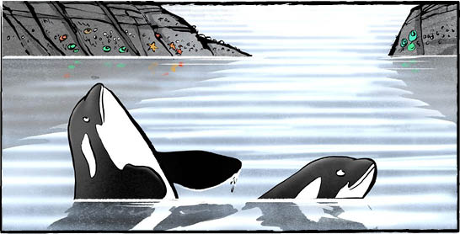  
 **Brave Little Hunter comes from a pod of Bigg’s orcas.   
They are also called ‘transient’ orcas because they are frequently on the move.**

**Comprehension Check**

Mark the statements **T** (True) or **F** (False). If a statement is ***true***, write one fact to support it on the lines below. If a statement is ***false***, write the word or words that make it true.

**1.** The baby orca’s way out of the lagoon was blocked by a sandbar.

**2.** The baby orca was named Brave Little Hunter.

**3.** The baby orca was lured out of the lagoon with meat.

**4.** The baby orca stayed in the lagoon for about a month.

**5.** The baby orca is five years old.

**6.** The baby orca can’t survive on her own.

**Language Focus**

A ***comma***, along with a ***conjunction*** (**and, but, or, for, nor, so**), is used to join two independent clauses (clauses that have a subject and a verb and can stand alone – complete sentences).

**Example**: It was a fun party. Now we are tired!

It was a fun party, but now we are tired!

***Add a comma and conjunction to connect each set of sentences.***

1. The baby orca was alone. She wasn’t old enough to survive.
2. She seemed to be healthy. They fed her some seal meat.
3. They tried herding her with boats. She was trapped.
4. Do you like orcas? Would you rather study whales?

**Can you join other independent clauses from the article together using a comma and a conjunction?**

Record-Breaking Mac and Cheese Domino Topple!

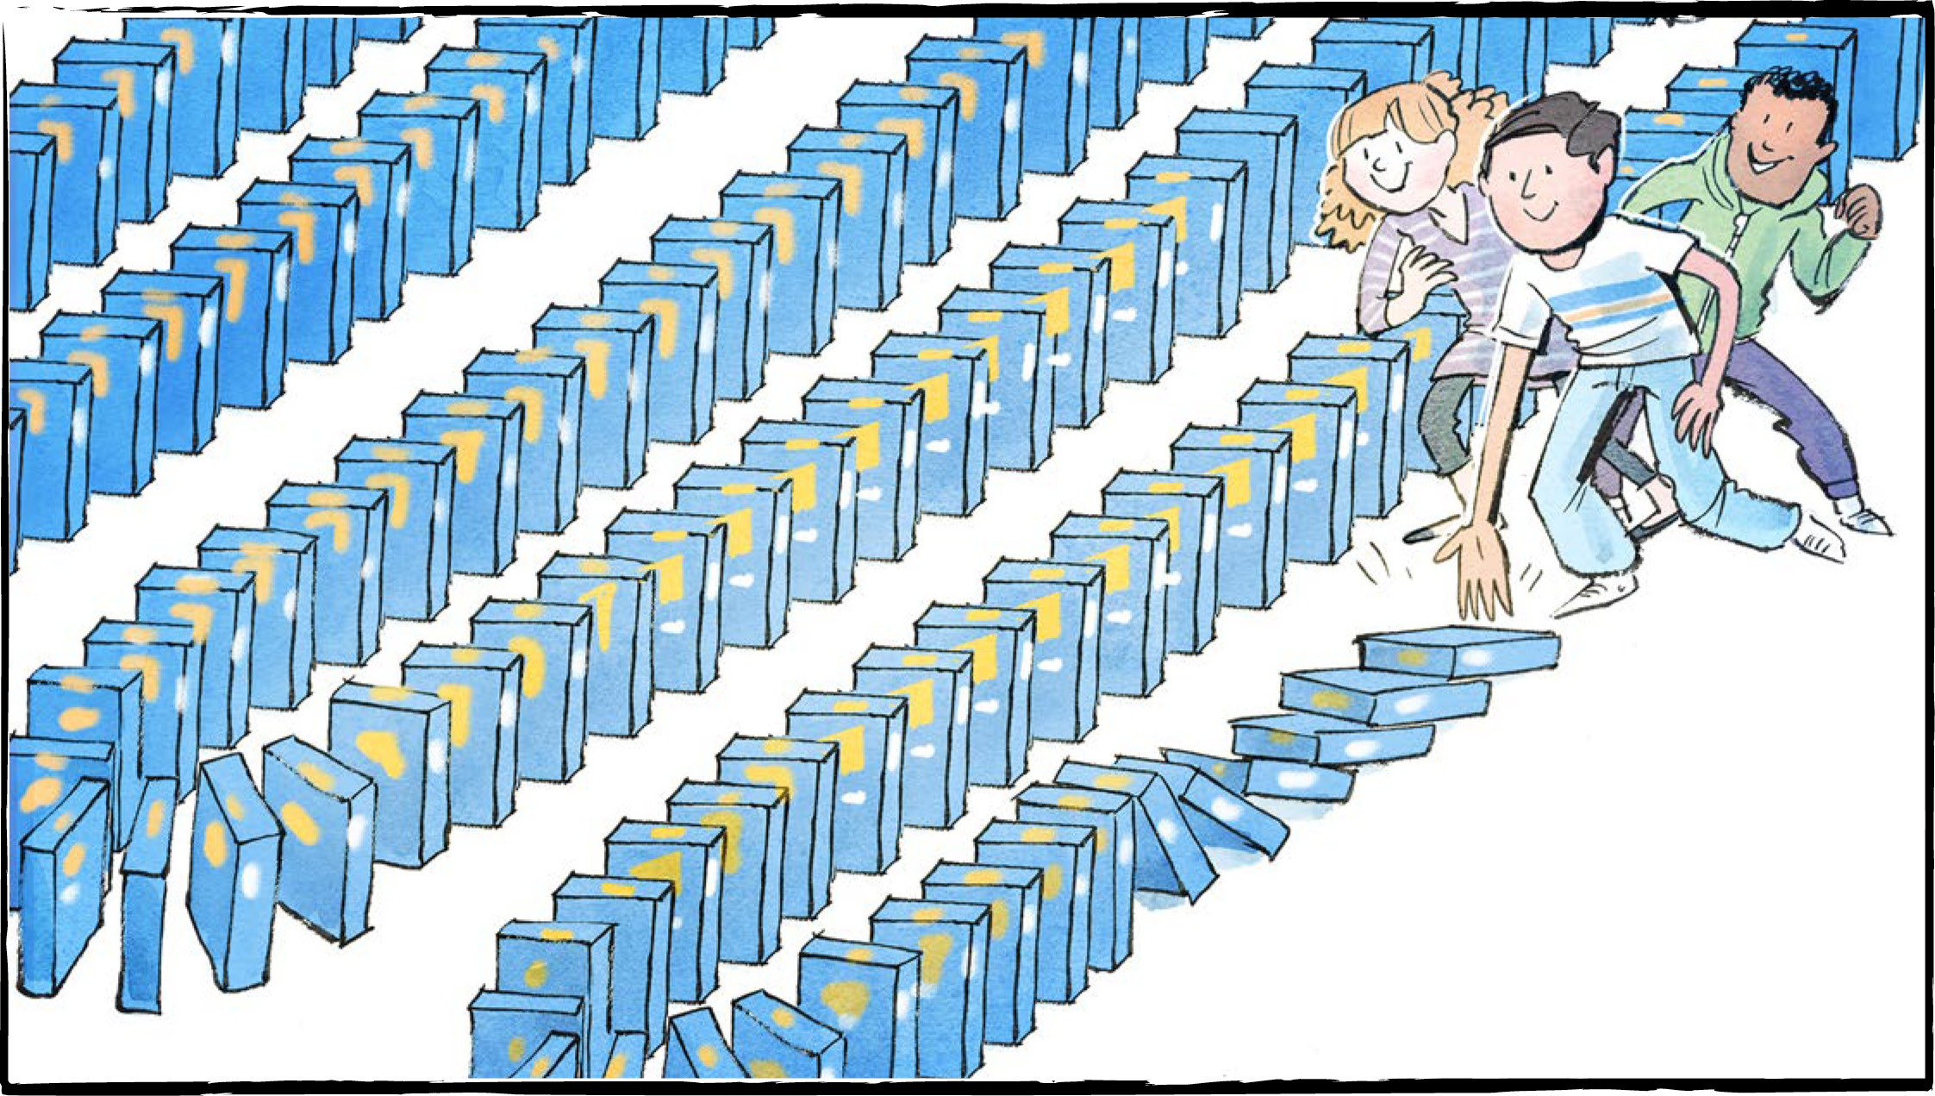

Have you ever knocked over a line of dominoes? The first one knocks over the next, which knocks over the next, then the next, and so on. Imagine doing the same thing using boxes of mac and cheese instead. Or, how about 12,500 boxes!

**World Record**

Several schools have taken on the challenge of toppling boxes of mac and cheese. The previous world record used 5000 boxes.

A teacher in North Battleford, Saskatchewan, decided his students could beat that. They would double the number of boxes! Set a new world record!

All for a good cause, of course. The boxes of mac and cheese would eventually go to the local food bank.

“I try to have my students be very involved in their community,” said teacher Dan Fox. “Let’s think of something fun and exciting we can do.”

“We’re teaching the next generation of students. But we’re also creating the next generation of citizens. I always want my students to be good citizens.”

**Preparations**

The call went out to the community. Please donate single-serve food boxes of Kraft mac and cheese. They received nearly 7000 boxes. The company that makes mac and cheese dinners donated a further 5500 boxes.

They had enough boxes. Could they make them all topple like dominoes?

A team of students practised at school to prepare for the big day. That morning they spent four hours setting up the blue and orange boxes on a gym floor. The line of boxes snaked back and forth. The boxes were perfectly spaced to knock each other over, even when going around the curves. There were more than enough to beat the world record.

**Game on!**

It was time! The community came out to support them. Others watched via live stream. Amidst cheers, clapping, and hollering, the boxes toppled over, one after another. All of them!

“So much fun!” said one student.

“Now we have to clean them all up,” said another, with a smile and a thumbs up.

**Did they beat the record?**

The topple had a few hiccups. It wasn’t perfect. It got stuck a few times, and needed someone to give it a nudge.

So did it set a new world record? The Guinness World Records people will look at the video and make that decision.

**It may not matter**

“As a community, we’ve already won,” said the director of the local food bank.

“Whether or not we break the record, we’re already winners.”

Dan Fox agreed. “I’m happy for the kids who put in all this work today.”

How will they celebrate if they find out they broke the record? It’s a no-brainer, says one Grade 6 student. With mac and cheese!

“If I win the Guinness World Record, I’m going to have to eat it,” she says.

What can you do to be involved in your community?

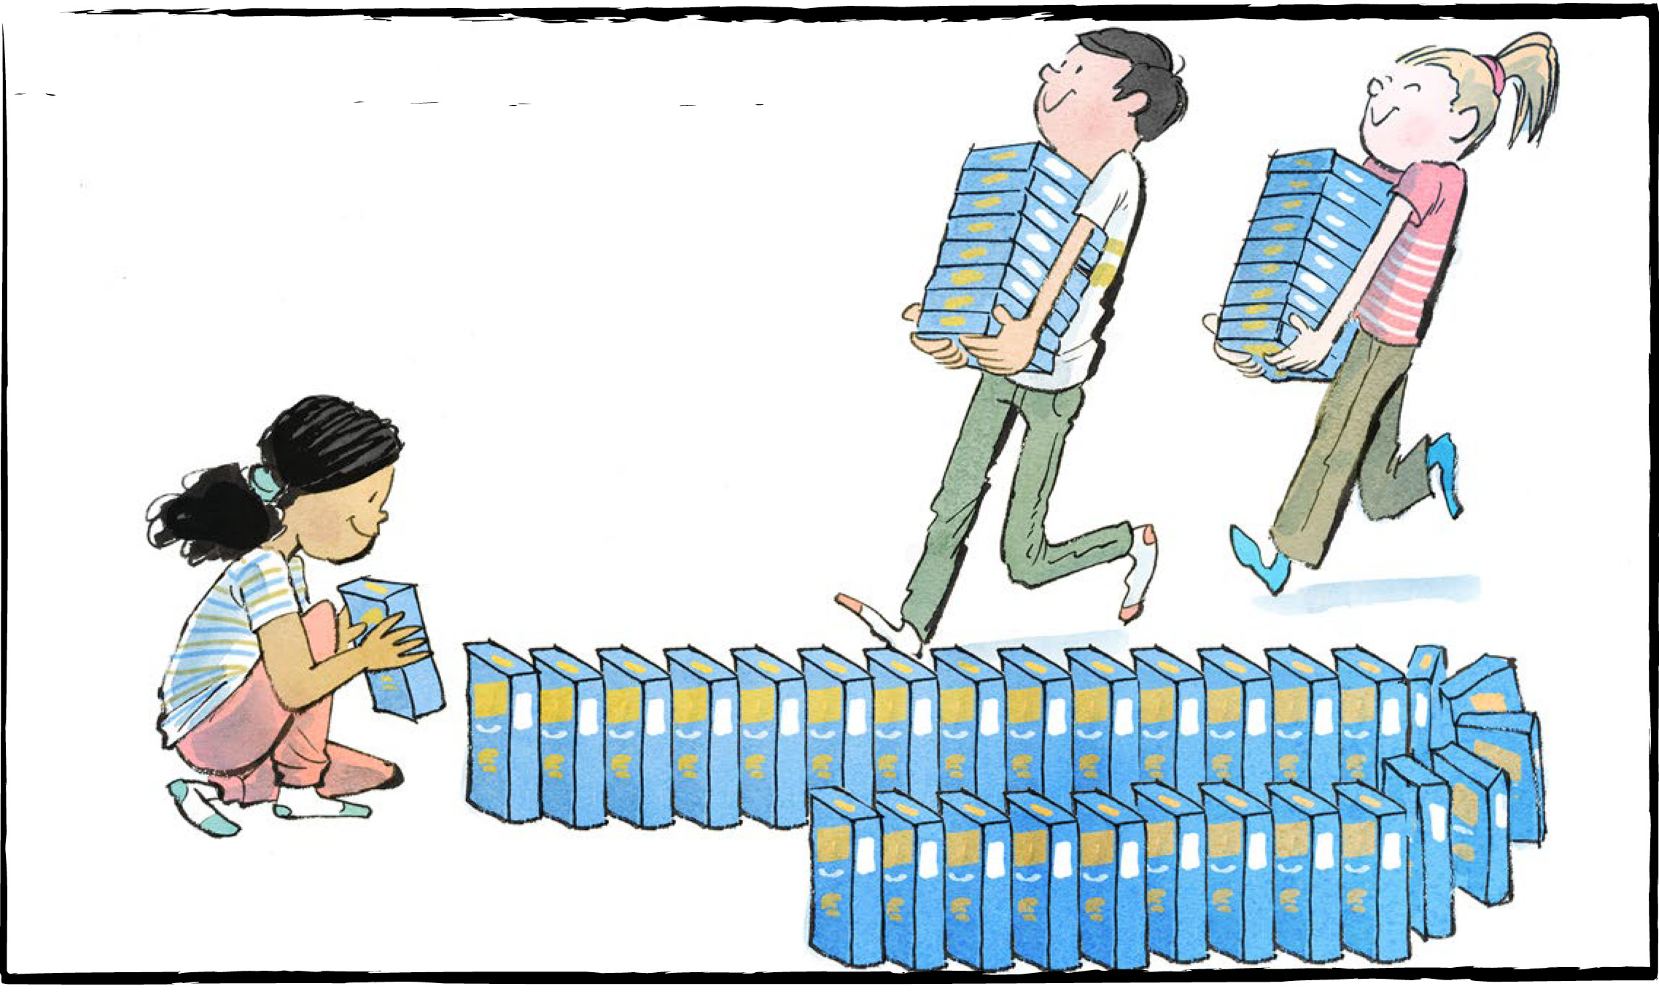

**Comprehension Check**

Answer the questions below in complete sentences:

1. Describe what it looks like to knock over a line of dominoes.
2. Where would the boxes of mac and cheese eventually go?
3. How many boxes did the company that makes mac and cheese dinners donate?
4. How long did it take to set up the blue and orange boxes on the gym floor?
5. How will the students celebrate if they find out they broke the record?

**Language Focus**

Nouns are words that name people, animals, places, things, and ideas.

***Concrete nouns*** can be identified through one of the five senses. An ***abstract noun*** cannot be identified through the senses. It is a quality, a concept, an idea, or maybe even an event.

**Directions**: Put the nouns from the list below into the proper category.

**Concrete Abstract**

pride soup jacket happiness

domino freedom line anger

courage bowl phone growth

Now find examples of concrete and abstract nouns in the article.

**Concrete Abstract**



