Articles and Questions

Each **free article** of ***The Canadian Reader*** includes:   
  
1) a PDF file

*and*

2) a Word file

These files contain **only** the article and questions. They do **not** contain Answer Keys.

This **Word** file allows students to complete assignments using a computer either at school or at home. Teachers can assign all or parts of the file by email attachment or a school website. The **Word** file also allows teachers to:

• easily modify and format content including changing *fonts* and text sizes

• create a PDF document and use Adobe Reader's 'Read Out Loud Mode'

• save paper and copying costs and help protect the environment

• promote and encourage students’ computer skills

What Else Can You Do With The Word File?

#1) You can easily upload the file to Google Docs and share it with students or other teachers. **See how here:**

<https://support.google.com/drive/answer/2424368?hl=en>

#2) Translate the uploaded document into another language. (see **Tools>Translate document**).Google Docs will create a new copy of the original file but you will need to edit the document to suit your requirements. Google Docs can translate into over 100 languages including Spanish, Mandarin, German, etc. **See how here:**

<https://support.google.com/docs/answer/187189?hl=en&co=GENIE.Platform=Desktop>

One Cool Coin

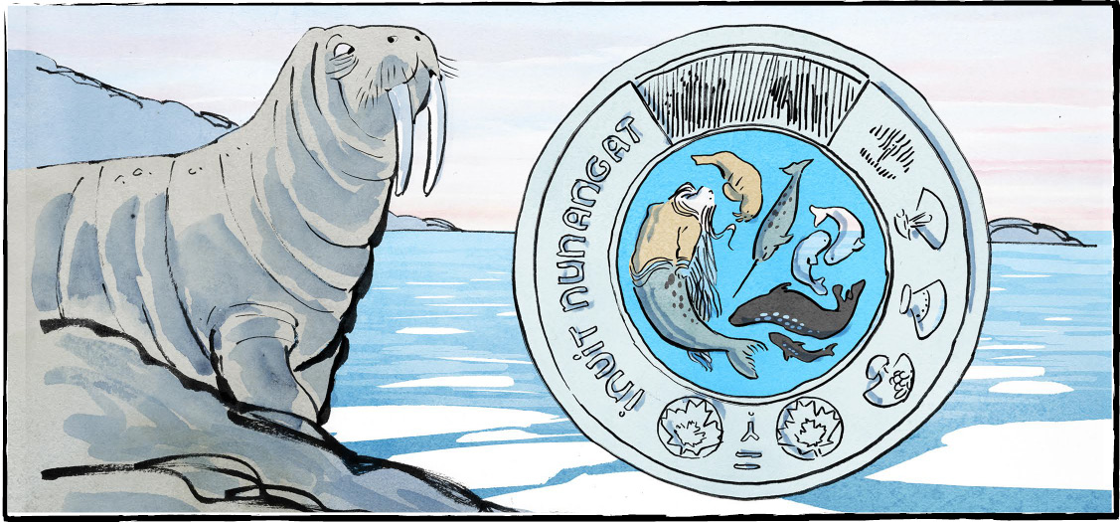

A “cool” new toonie coin is on its way to Canadians. The coins were released November 7. You may already have seen one!

The coin is called Inuit Nunangat. That means Inuit homeland. These special coins celebrate the Inuit culture and way of life.

The Royal Canadian Mint will make three  
million of the coins. Two million will be  
coloured.

**Four artists, four regions**

Four Inuit artists worked together to design the toonie. One artist came from each of the four Inuit regions.

Mary Okheena is from Ulukhaktok. Ulukhaktok is in the Inuvialuit Settlement Region. The region is also called Inuvialuit Nunangat, or Inuvialuit homeland. This region is the farthest west of the four. It has a population of about 12,000.

Charlotte Karetak comes from Arviat, Nunavut. Nunavut means “our land.” Nunavut is the largest of the four regions. It reaches the furthest north. Its population is about 27,000. Arviat sits on the west shore of Hudson Bay.

Thomassie Mangiok is from Ivujivik, in Nunavik. Nunavik means “the great land.” Nunavik is east of Hudson Bay. It includes northern Québec. Nunavik is home to about 11,000 people.

Tegan Voisey comes from Makkovik, Nunatsiavut. Nunatsiavut means “our beautiful land.” It includes the northern parts of Labrador. The region is about the size of New Brunswick. About 2300 people call it home.

**Long-distance groupwork**

The four artists faced one big challenge—distance. “We were separated by hundreds or thousands of kilometres,” Mr. Mangiok said. They had to deal with Internet issues. Different time zones caused challenges, too.

The artists felt it was important to work together. Inuit Nunangut can’t “be represented by one region alone,” Ms. Voisey said. Each region is different. The coin celebrates both differences and shared experiences.

**Imagery**

The inner circle of the coin shows Nuliajuk, the spirit of the sea. In the coloured version of the coin, the sea is bright blue.

Nuliajuk wears an atigi, or a parka. Her seal tail lets her swim. On the coin, sea creatures swim with her. These include a walrus, a narwhal, and two beluga whales. A seal and an arctic char are also shown.

The outer circle of the coin shows four uluit. These are traditional knives. Ulu handles are made of animal bone. The Inuit always use as much of an animal as possible.

Each ulu (knife) represents one of the four regions. “Our uluit are made slightly different in each region,” Mr. Magniok said. Yet, they are the same tool. “We Inuit have different dialects and practices, but we all live the same way,” the artist added.

The other side of the coin shows King Charles III. Canadian artist Steven Rosati created the King’s image.

**Coming together**

Ms. Karetak hopes the coin will make Canadians think. “We live in such a beautiful territory,” the artist said. She wants people to respect the land and animals and all that nature can offer.

Finally, she hopes the coin will remind Canadians to respect each other.

As you see it, what is the importance of these "cool" new toonies?

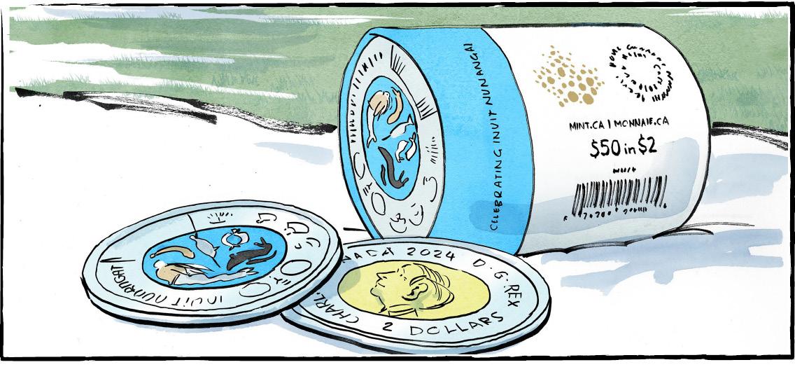

**The Inuit homeland covers about 40 percent of Canada’s   
land mass and over 70 percent of its coastline!**

**Comprehension Check**

Answer the questions below in complete sentences:

**1.** When were the new toonie coins released?

**2.** How many coins will the Royal Canadian Mint make?

**3.** Which artist is from Ivujivik?

**4.** List three challenges faced by the artists.

**5.** Which sea creatures swim with Nuliajuk on the coin?

**6.** What image is shown on the outer circle of the coin?

**Language Focus**

**Connect the words with their definition.**

to show high regard for something or someone **homeland**

an area of land that has common features **culture**

a difficult task or problem **region**

a place where a person feels they belong **distance**

how far one thing is from another **challenge**

customs handed down from one generation to another **traditional**

a system of shared beliefs, values, and customs **dialect**

a way of speaking that is common to a particular place **respect**

**Now use three of these words in your own sentences.**

1.

2.

3.

