Articles and Questions

Each **free article** of ***The Canadian Reader*** includes:   
  
1) a PDF file

*and*

2) a Word file

These files contain **only** the article and questions. They do **not** contain Answer Keys.

This **Word** file allows students to complete assignments using a computer either at school or at home. Teachers can assign all or parts of the file by email attachment or a school website. The **Word** file also allows teachers to:

• easily modify and format content including changing *fonts* and text sizes

• create a PDF document and use Adobe Reader's 'Read Out Loud Mode'

• save paper and copying costs and help protect the environment

• promote and encourage students’ computer skills

What Else Can You Do With The Word File?

#1) You can easily upload the file to Google Docs and share it with students or other teachers. **See how here:**

<https://support.google.com/drive/answer/2424368?hl=en>

#2) Translate the uploaded document into another language. (see **Tools>Translate document**).Google Docs will create a new copy of the original file but you will need to edit the document to suit your requirements. Google Docs can translate into over 100 languages including Spanish, Mandarin, German, etc. **See how here:**

<https://support.google.com/docs/answer/187189?hl=en&co=GENIE.Platform=Desktop>

The Story of a Store

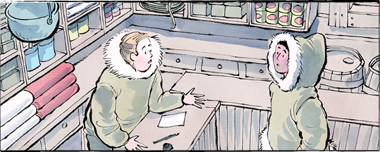

The Hudson’s Bay Company. The Bay. HBC. Have you heard of it? Maybe you have even shopped there.

The company began as a collection of fur-trading outposts. It became a major department store chain. Today there are 80 Hudson’s Bay stores across Canada.

Soon there will be six: three in Toronto, three in Montreal.

Even those might not last. If those stores close, it will be the end of a very long story.

**Long ago and far away**

On May 2, 1670, King Charles II of England signed a paper. The Hudson’s Bay company traces its roots to that paper. Back then, it was called “The Governor and Company of Adventurers of England Trading into Hudson’s Bay.” Catchy!

The paper let the company use land around Hudson Bay. Its people could live and trade there. The land was almost four million square kilometres in size.

**A way of life disrupted**

Indigenous Peoples have lived on that land since time immemorial. They had their own trade networks. They had their own traditions and ways of life.

The Hudson’s Bay company upset all that. Beaver pelts were what the HBC wanted most. Beaver fur was used to make felt hats. These were in high demand in Europe.

Over time, the company grew. The Indigenous Peoples suffered. The fur trade  
changed their economy. Settlers and  
traders brought disease. They bargained  
unfairly for land.

In 1867, Canada became a country. Soon after, it bought the land “owned” by the Hudson’s Bay company.

The trading company stayed in business. It sold goods to settlers. It opened its first department store in 1881, in Winnipeg. From there, the company expanded.

**An everything store**

Have you been in a Hudson’s Bay store? What were you looking for? Department stores are “everything” stores. They sell furniture, clothes, toys and tools… everything.

Some Hudson’s Bay stores are many floors high. It costs a lot to rent a space like that. That may have been part of the problem.

**The way we shop**

People don’t shop the same way anymore. Big stores like Walmart also sell “everything,” at lower prices. For expensive items, people go to specialty stores.

The Internet caused an even bigger shift. People can shop without leaving home. Online there are more options than any store could carry.

This is bad news for stores like Hudson’s Bay.

**Emptying stores**

Canada’s oldest company is in trouble. It owes a lot of money. It cannot pay its debts.

Hudson’s Bay has started “liquidating” most of its stores. That means items are being sold, often at a discount. Nothing will be re-ordered. The goal is to empty the stores. At the end of June, the stores will close.

The story of the Hudson’s Bay company is not yet over. If things don’t change, though, it may be coming to an end.

Present-day Canada covers about ten million square kilometres.

Where do you prefer to shop?

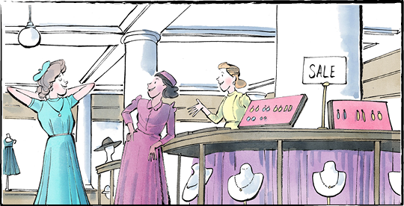

**The Hudson’s Bay Company is more than 350 years old!**

**Comprehension Check**

Mark the statements **T** (True) or **F** (False). If a statement is ***true***, write one fact to support it on the lines below. If a statement is ***false***, write the word or words that make it true on the lines below.

**1.** Today there are 80 Hudson’s Bay stores across Canada.

**2.** Indigenous Peoples have lived on the land around Hudson Bay since time immemorial.

**3.** In 1670, Canada became a country.

**4.** The Hudson’s Bay company opened its first department store in Toronto.

**5.** Department stores only sell furniture.

**6.** Hudson’s Bay owes a lot of money.

**Language Focus**

An ***adjective*** is a word that describes a noun. Add adjectives to the sentences below, using words from the list or your own ideas:

1. The Hudson’s Bay Company has a _______________ history that stretches back over 350 years.

2. The company built _______________ stores filled with clothes, furniture, and tools.

3. Some people remember the stores as _______________ places to shop during holidays.

4. The loss of HBC stores feels like a _______________ moment in Canadian history.

5. For Indigenous Peoples, the arrival of traders was a _______________ change to their way of life.

6. The Internet caused a shift, making online shopping _______________ .

7. Now, many of the stores are _______________ , waiting to be closed forever.

**amazing long brave special   
quiet different old big   
sad positive kind-hearted new   
sudden empty expensive newfound  
busy unfair popular traditional**

**In what ways do adjectives make writing stronger?**

