Articles and Questions

Each **free article** of ***The Canadian Reader*** includes:   
  
1) a PDF file

*and*

2) a Word file

These files contain **only** the article and questions. They do **not** contain Answer Keys.

This **Word** file allows students to complete assignments using a computer either at school or at home. Teachers can assign all or parts of the file by email attachment or a school website. The **Word** file also allows teachers to:

• easily modify and format content including changing *fonts* and text sizes

• create a PDF document and use Adobe Reader's 'Read Out Loud Mode'

• save paper and copying costs and help protect the environment

• promote and encourage students’ computer skills

What Else Can You Do With The Word File?

#1) You can easily upload the file to Google Docs and share it with students or other teachers. **See how here:**

<https://support.google.com/drive/answer/2424368?hl=en>

#2) Translate the uploaded document into another language. (see **Tools>Translate document**).Google Docs will create a new copy of the original file but you will need to edit the document to suit your requirements. Google Docs can translate into over 100 languages including Spanish, Mandarin, German, etc. **See how here:**

<https://support.google.com/docs/answer/187189?hl=en&co=GENIE.Platform=Desktop>

**Eyes on the Skies!**

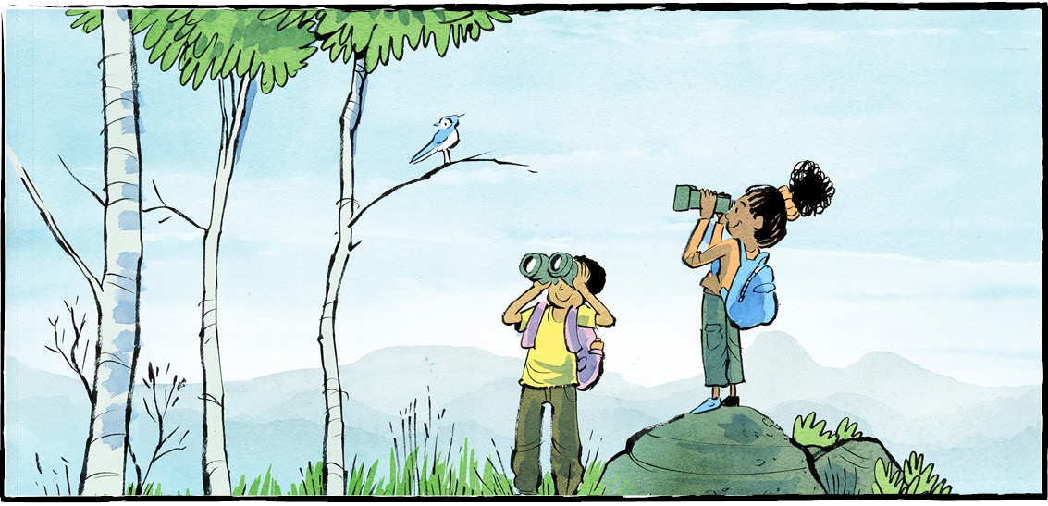

Quick, look outside! Do you see any birds? Can you name the species?

**Starting young**

Jeremie Corbeil is thirteen years old. He lives in North Bay, Ontario. Jeremie has been a birder for at least four years. In that time, he has spotted more than 150 species of birds!

Other birders envy his sharp senses. “They say it’s great to start at a young age,” Jeremie says. “It’s easier to hear and it’s easier to see.”

Another birder, Greg Blomme, is an adult now. He wasn’t when he got started. He was a young kid with energy to burn. Birding was his father’s hobby.

He remembers his father telling him, “Hey, go scare up those birds.” He would jump into ponds or hit trees with sticks. His father would see what birds appeared.

**Birding online**

Birding used to be seen as an old person’s hobby. That’s no longer true. Young people are flocking to birding. That may be why the hobby is getting a technology boost.

Fisher Stephenson is a university student in Calgary. He spends his afternoons birding. He posts his best bird photos on Instagram.

Mr. Stephenson says younger birders connect with each other online. They use group chats. Social media. Digital photography.

Other birders use WhatsApp and Discord to share bird sightings. On TikTok, the hashtag #birdwatching has 1.9 billion views!

There are apps for birdwatchers, too. ‘Merlin’ analyzes birdsong to tell people what birds are around. ‘eBird’ lets people add the birds they see to an online database. This helps scientists and researchers.

**Getting started**

Birding can be a lifelong hobby. Some people keep a wishlist of birds they’d like to see. Some even go on organized birdwatching trips.

Birding doesn’t require fancy equipment. You can start in your own schoolyard, backyard, or balcony.

If you can, set up a bird feeder. Find out what foods local birds like.

You will need help identifying the birds you see. Look for a book or webpage about local birds. You might also want a notebook, to track your findings.

Binoculars are nice to have. Fancy apps are optional.

Start by training your observation skills. When you see a bird, what do you notice about it? How big is it? What colours do you see? What shape is its beak?

Watch it in motion. Different birds use different movements when they fly. Woodpeckers fly with a ‘hopping’ motion.

**Mental health benefits**

Birding is good for your mental health. A 2022 study backs this up. The study said seeing or hearing birds makes you feel better. The effect lasts up to eight hours!

Even backyard birders see benefits. Birding requires patience. You must be present in the moment.

Listening to birdsong can be calming. Plus, birdwatching gets you out in nature.

Birdwatching is fun, easy, and good for you. Train your eyes on the skies!

What would you like to ask Jeremie about birding?

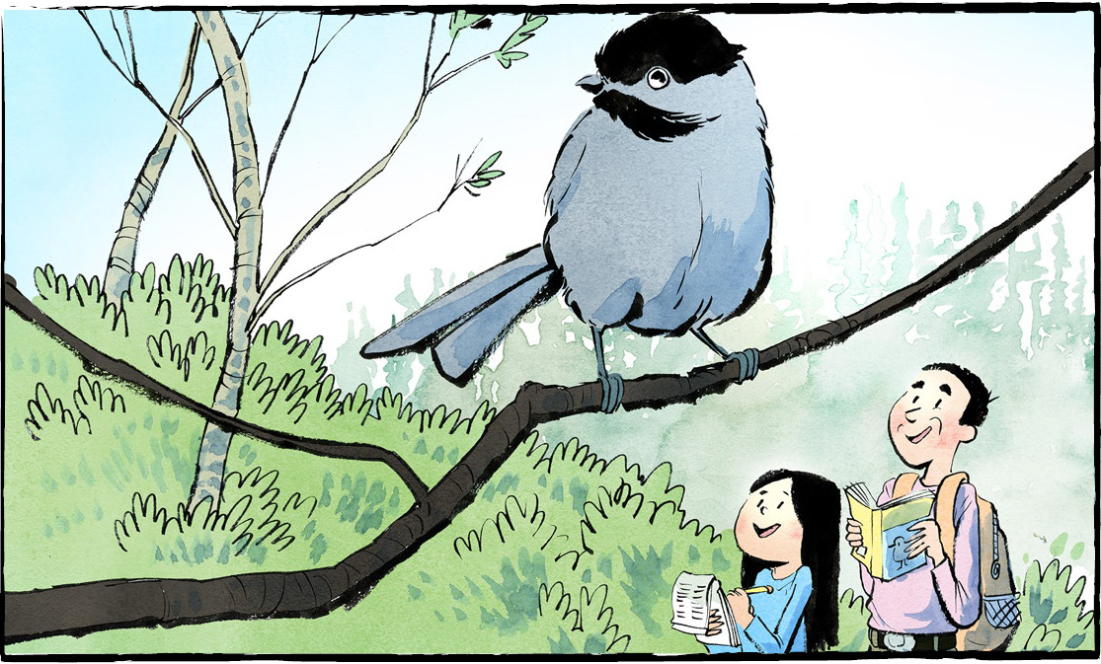

**Comprehension Check**

Answer the questions below in complete sentences:

1. How long has Jeremie Corbeil been a birder?

2. How did Greg Blomme “scare up those birds”?

3. How do younger birders connect with each other online?

4. How does the app ‘Merlin’ help birdwatchers?

5. List three ways birding is good for your mental health.

**Language Focus**

Write the vocabulary word or phrase from the box at the bottom of the page beside its definition.  
  
 1. A group of living organisms.

2. An activity done for fun

3. Became visible

4. Coming together in large numbers

5. A collection of words, numbers, images,  
 or videos

6. Lasting throughout a person's life

7. The necessary items for a particular purpose

8. An advantage

9. Possible but not necessary

10. The hard pointy part of a bird's mouth

**beak species hobby benefit flocking   
lifelong equipment optional appeared database**

**Comprehension Check**

Answer the questions below in complete sentences:

**1.** What is a park

**2.** What can people do in parks

**3.** Name the first provincial park. Where is this park located?

**4.** Name the first national park. When was this park created?

**5.** How many people visited Canada's national parks in 2022-2023?

**Tell a partner which park you like the most and explain why this park is your favourite.**