Article and Questions

This Breaking News issue includes:
1) a PDF file (the complete document)
and
2) a Word file that contains only the article and questions.

These files contain only the article and student activities. They do not contain the Answer Key.

The Word file allows students to complete assignments using a computer either at school or at home. Teachers can assign all or parts of the file by email attachment or a school website. The Word file also allows teachers to:
• easily modify and format content including changing fonts and text sizes
• create a PDF document and use Adobe Reader's 'Read Out Loud Mode'
• save paper and copying costs and help protect the environment
• promote and encourage students’ computer skills

Insurrection In The United States
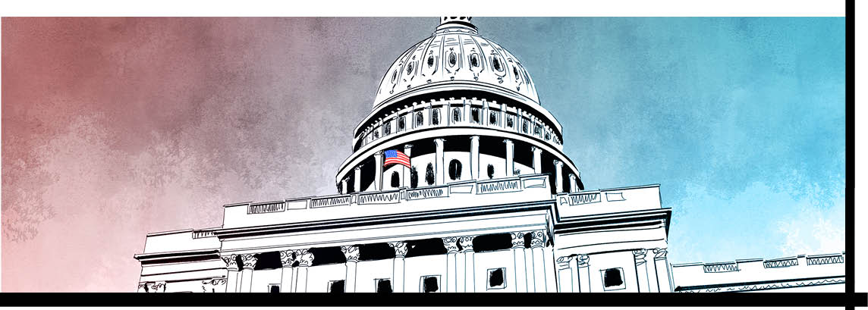

It was an event usually seen in undemocratic countries. For several hours, swarms of rioters smashed the windows of the legislature. They rampaged through government corridors. They vandalized offices. And they forced panicked lawmakers, fearing for their lives, to take shelter.
The mob also called for the death of high-ranking politicians. Some even placed pipe bombs in key locations to help them carry out these threats. Police tried to hold back the rioters, but the officers were greatly outnumbered.
This scene didn't unfold in an authoritarian nation, however. It took place in the United States, a country that is considered to be a bedrock of democracy. The site of this chaos? Washington, D.C., the nation's capital.
A Powder-Keg Rally
The insurrection took place on January 6, following a mass rally held by U.S. President Donald Trump.
On that date, all members of the U.S. Congress had gathered to certify the results of the 2020 presidential election. This is a symbolic ceremony that happens after every four years when the next president is chosen. It celebrates the peaceful transfer of power from one president to another. Vice President Mike Pence was presiding over the event as the day unfolded.
Mr. Trump's rally was a last-ditch attempt to stop this process. The reason? Mr. Trump, a Republican, never accepted the outcome of the November 2020 election. For more than two months, he falsely claimed that the election results were rigged. He said that he had won, and Joe Biden, a Democrat, had lost.
Mr. Trump offered no evidence for these assertions. In fact, judges in more than 50 court cases ruled that the election was fair. Yet he still insisted that the election was stolen from him.
‘Will Be Wild!’
Many of his followers became convinced this was true. They were egged on by extreme right-wing commentators, Republican politicians afraid to alienate Mr. Trump, and Internet conspiracy theories. When Mr. Trump urged them to come to Washington to protest, thousands of people from across the country made the trip. ‘Be there. Will be wild!,' Mr. Trump tweeted.
At the rally, President Trump appeared to encourage the crowd to take action against the government.
“We’re going to have to fight much harder..." he told them. "We’re going to walk down [to Congress] and I’ll be there with you...Because you’ll never take back our country with weakness. You have to show strength.”
He also said he was angry at Mike Pence. President Trump had urged the vice president not to certify the election during the January 6 ceremony. But Mr. Pence refused this demand.
VP In The Crosshairs
So after the rally, thousands of furious Trump supporters marched to the Capitol building where Congress was meeting. They easily broke through barriers. Hundreds stormed into the legislature. Some shouted “Where’s Mike Pence” while looking for politicians to confront.
For four hours, they ransacked files, displayed hate-filled messages, and took selfies. Lawmakers and staff sheltered in place or were whisked away through secret underground tunnels to safety. Police shot and killed a woman in a standoff. In the end, five people died, including a police officer.
Hours into the chaos, Mr. Trump tweeted a message to the rioters. But he didn’t denounce the violence.
“This was a fraudulent election, but we...have to have peace. Go home, we love you, you’re very special,” he told the rioters.
Democracy Prevails
Around 6 p.m., when reinforcements arrived, police were finally able to gain control and secure the building. Lawmakers were badly shaken, but this assault on democracy only made them more resolute about performing their duty. They returned to Congress at 8 p.m. Late that night, a determined Mr. Pence certified Mr. Biden's victory.
“Violence never wins; freedom wins; and this is still the people’s house,” he declared.
Now, police have launched a nationwide search to find the Capitol attackers. More than 170 suspects could face prosecution. Meanwhile, expect a deep probe into why police failed to protect the Capitol building.

A Second Impeachment For Mr. Trump
On January 12, President Donald Trump was impeached for the second time – a unique event in U.S. history.
What exactly is an impeachment? It's the situation that occurs when lawmakers in the U.S. House of Representatives vote in favour of putting a president on trial for an alleged misconduct. All it takes for an impeachment is a simple majority of members.
In this case, every Democrat and 10 Republicans voted to impeach Mr. Trump for 'incitement of insurrection'. The vote was 232 to 197.
The U.S. Senate conducts impeachment trials. The Chief Justice of the U.S. Supreme Court usually presides. Witnesses are called on both sides and senators serve as the jury. Two-thirds of the senators must vote against the president. A guilty verdict removes a president from office. The Senate acquitted Mr. Trump the first time of illegally withholding aid from Ukraine. If he loses this time, it will be too late to remove him from office. But he can be banned from running for president again.

acquit: to pronounce not guilty of criminal charges
alienate: to cause someone to stop being friendly or helpful
assertion: the act of forcefully expressing your opinions
bedrock: a strong idea, principle, or fact that supports something
denounce: to publicly say that someone or something is bad
incitement: the act of encouraging somebody to do something violent, illegal, or unpleasant
insurrection: a usually violent attempt to take control of a government
preside: to be in charge of something, such as a meeting
resolute: strong and determined
right wing: the part of a political group that supports conservative or traditional ideas and policies
U.S. Congress: the legislature of the federal government of the United States that consists of 435 members of the House of Representatives and 100 members of the Senate

Comprehension Questions

1. What is the U.S. Congress? What are the two parts of this institution?

2. What was planned at the U.S. Congress on January 6? What is the vice president’s role in this event?

3. Who hosted a large public rally in Washington on the morning of January 6?

4. What message did the president convey at the rally? How did he incite the protesters to take action?

5. Describe what Trump supporters did when they reached the Capitol where Congress was meeting.

6. How did the police respond to this assault?

7. What happened after the demonstrators were removed from the Capitol building?

8. What did the House of Representatives do on January 12? What was the charge against Mr. Trump?

9. What is the second step in the impeachment process? Explain.

Questions For Further Thought
1. While the January 6 insurrection was taking place, President Trump released a video statement to his supporters from the White House: “This was a fraudulent election, but we can’t play into the hands of these people. We have to have peace. So go home, we love you, you’re very special.”
In any message, there are explicit ideas that are obvious and clear, and implicit ideas that are suggested or implied. In your opinion, what are the explicit and implicit ideas in President Trump's message to his supporters? Give reasons to support your ideas.

2. Late on the evening of January 6, once the Capitol building was secured, Vice President Mike Pence presided over the certification of the election results. He stated, “Violence never wins; freedom wins; and this is still the people’s house.”
As you see it, what message was the vice president sending in this statement? Explain.

Questions For Online Exploration
Note: The links below are listed at www.lesplan.com/en/links for easy access.
1. President Trump has delivered many messages to the American people during and since the insurrection at the Capitol building, in different settings and circumstances. Visit the links below to watch the progression of these messages over time:
January 6, rally: https://www.yout-ube.com/watch?v=6quOC6McLZU
January 6, during the insurrection: https://www.yout-ube.com/watch?v=aMeAE4GHmIE
January 7, formal announcement: https://www.yout-ube.com/watch?v=iFADopBnb_U
January 8, formal announcement: https://www.yout-ube.com/watch?v=qfNTxW1Jhc0
January 12, on the White House lawn https://www.yout-ube.com/watch?v=aLjfWxy2qjo
January 13, formal announcement: https://www.yout-ube.com/watch?v=hDNiNdsPHNA
As you see it, has the president been consistent with his messaging? Give reasons to support your ideas.

2. With just over a week left in Donald Trump's presidency, the U.S. Congress voted to impeach the president. Visit either of the sites below to learn about the impeachment vote and what it might mean for Donald Trump as he leaves office:
https://www.yout-ube.com/watch?v=crq196edW6M
https://www.yout-ube.com/watch?v=ptsU235pU1k
Do you agree with the U.S. Congress' decision to impeach President Trump? Explain.

Putting It All Together
A. Write the letter that corresponds to the best answer on the line beside each question:
______ 1. On January 6, all members of the U.S. Congress met to:
a) impeach the vice president b) certify the November election results
c) re-elect President Trump d) swear in Joe Biden as president
______ 2. Who was in charge of this process?
a) Nancy Pelosi b) Mike Pence
c) Donald Trump d) Barack Obama
______ 3. The impeachment charge brought against President Trump was: ‘______ of insurrection’
a) counseling b) conspiracy
c) incitement d) involvement
B. Mark the statements T (True) or F (False). If a statement is True, write one important fact to support it on the line below. If a statement is False, write the words that make it true on the line below.
______ 4. True or False? The vice president ignored Mr. Trump’s request to declare the election invalid.
______ 5. True or False? At a rally on January 6, Mr. Trump urged his supporters to protest peacefully.
______ 6. True or False? All Republicans voted to impeach Mr. Trump; all Democrats were opposed.
C. Fill in the blanks to complete each sentence.
7. The House of Representatives + the Senate = the U.S. _______________________ .
8. Mr. Trump _______________________ claimed the recent presidential election was rigged.
9. Very few police officers were protecting the U.S. _______________________ building on January 6.
D. Respond to the following question in paragraph form. (Use a separate sheet of paper if necessary.)
10. As you see it, should Donald Trump be held accountable for the insurrection on the Capitol carried out by his supporters? Give reasons to support your response.

